**A CRM APPLICATION TO MANAGE THE SERVICES OFFERED BY AN INSTITUTION**

**By**

**Name : R Sreeja**

**Email ID : rsreeja2487@gmail.com**

# **PROJECT ABSTRACT**

EduConsultPro Institute, a premier educational institution offering diverse courses and programs, encountered significant challenges in managing its growing number of student inquiries, admission processes, and expert consulting services. To address these challenges, a Customer Relationship Management (CRM) application was developed using Salesforce. The primary objective of this project was to streamline the admission process, providing a seamless and transparent experience for prospective students, while enabling admissions staff to manage applications, inquiries, and case management efficiently. The CRM application integrates and automates key processes, enhancing operational efficiency and optimizing the workflow. This solution not only improves the user experience for students but also empowers the institution's staff to deliver timely and effective services, thereby supporting EduConsultPro's mission to offer exceptional educational opportunities.

**INDEX PAGE**

**TASK NO . TITLE PAGE NO.**

## **Task 1 CREATE OBJECTS**

1.1 Create Course Objects 5

1.2 Create Additional Objects 6

1.3 Relationship Among Objects 8

1.4 Configure Case Object 9

1.5 Lightning App Creation 10

## **Task 2 CREATE STUDENT ADMISSION FLOW**

2.1 Add Screen Element 11

2.2 Create Records 12

2.3 Add Decision Element 13

2.4 Add GetRecord Element 14

2.5 Create Email Template 15

2.6 Add Action Element 17

### **Task 3 CREATE USERS**

3.1 Create Users 18

3.2 Configure Settings 19

## **Task 4 CREATE APPROVAL PROCESS**

4.1 Create Email Template 21

4.2 Create Approval Process 22

## **Task 5 CREATE RECORD TRIGGERED FLOW**

5.1 Configure Start Element 23

5.2 Add Action Element 24

## **Task 6 CREATE APPOINTMENT BOOKING FLOW**

6.1 Add Screen Elements 25

6.2 Add Get Record Elements 26

6.3 Add Decision Elements 27

6.4 Create Records 29

6.5 Add Sub Flow Elements 30

## **Task 7 CREATE UNIFIED SCREENFLOW**

7.1 Add Screen Elements 31

7.2 Add Decision Elements 32

7.3 Add Sub Flow Elements 34

**Task 8**  **CREATE A LIGHTNING APP PAGE** 36

# **INTRODUCTION**

EduConsultPro Institute is a prominent educational organization committed to providing highquality educational opportunities across a wide range of disciplines. As the institute has grown, so too has the complexity of managing its admission processes, consulting services, and immigration case handling. The traditional methods of managing these functions have become increasingly cumbersome, leading to inefficiencies and challenges in delivering a streamlined and effective experience for both prospective students and institutional staff.

In response to these challenges, this project focuses on the development and implementation of a

Salesforce-based Customer Relationship Management (CRM) application. The objective of this CRM application is to automate and enhance the management of admissions, consulting services, and immigration cases, thereby improving operational efficiency and the overall experience for users.

Admission Application Management is a critical component of the CRM system, designed to simplify the application process for prospective students. The system enables students to submit comprehensive applications online, with automated notifications and analytical tools for admissions staff to track and assess application metrics effectively.

The Approval Process functionality ensures that consulting requests are efficiently reviewed and approved. The system includes automated workflows and email alerts to keep students informed of their request status, thereby streamlining the consulting approval process.

For Consulting Services Management, the CRM application provides a centralized platform for students to request consulting services, manage their requests, and schedule appointments. Automated notifications and an intuitive interface for consultants enhance the management and fulfillment of consulting services.

In the domain of Immigration Case Management, the CRM system facilitates the initiation, tracking, and processing of immigration cases. By integrating document management and communication tools, the system supports immigration agents and case managers in handling cases efficiently.

This CRM application represents a significant advancement in the way EduConsultPro Institute manages its student interactions and internal processes. By leveraging

Salesforce's powerful features, the project aims to deliver a more organized, efficient, and user-friendly experience for all stakeholders involved.

**TASK 1**

# **CREATE OBJECTS**

To streamline the setup of objects in Salesforce, we will begin by uploading the provided spreadsheets directly into the system. This process allows us to efficiently create and populate Salesforce objects using the existing data in the spreadsheets. By leveraging this method, we ensure a swift and accurate integration of information into Salesforce, facilitating a smooth setup for the CRM system. In the following tasks, we’ll walk through each step required to complete the object creation process and ensure that all data is correctly imported and configured.

## **1.1 CREATE COURSE OBJECTS**

* Go to the Object Manager in Salesforce and select the option to create an object from a spreadsheet.
* Click on the link provided to download the spreadsheet for the Course object.
* After downloading the spreadsheet, upload the file into Salesforce.

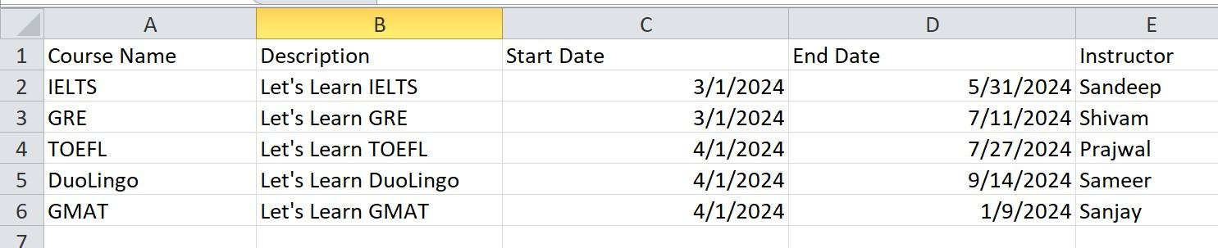

**Fig. 1.1.1 Course Object Spreadsheet**

* Map the fields from the spreadsheet to the corresponding Salesforce fields.

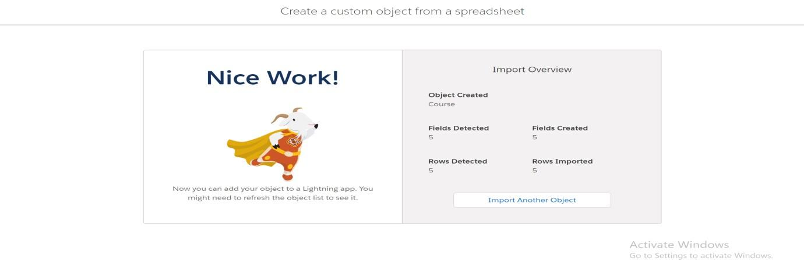

**Fig. 1.1.2 Course Object Imported Sucessfully**

* Finalize the upload to create the Course object.

## **1.2 CREATE ADDITIONAL OBJECTS**

Following the same procedure used for the Course object, I have created the remaining objects in Salesforce: Consultant, Student, and Appointment. To begin, I navigated to the Object Manager and selected the option to create each object from its respective spreadsheet. I downloaded the spreadsheets for Consultant, Student, and Appointment, then uploaded each file into Salesforce. For each upload, I mapped the fields from the spreadsheets to the corresponding Salesforce fields and finalized the upload to create the objects. This process ensured that all required objects were set up accurately and efficiently in the Salesforce CRM system.

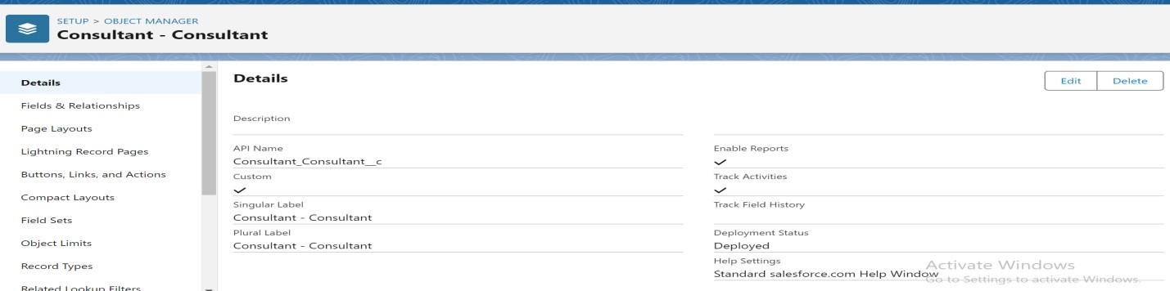

**Fig.1.2.1 Consultant Object**

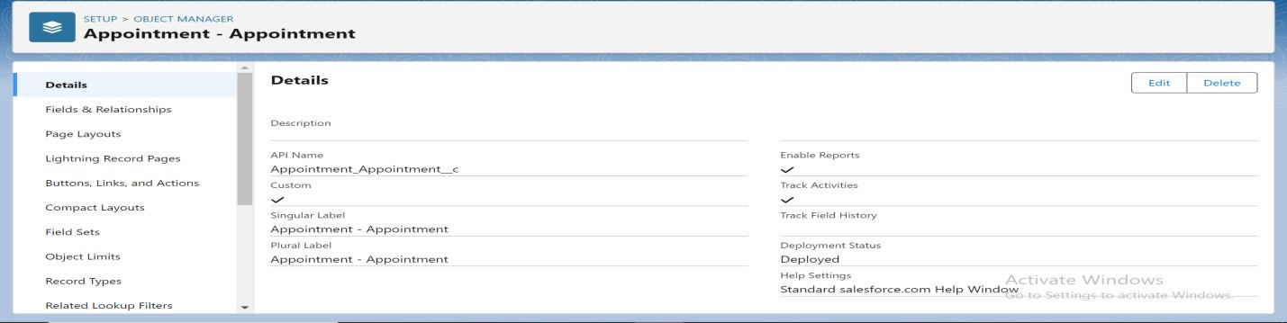

**Fig.1.2.2 Appointment Object**

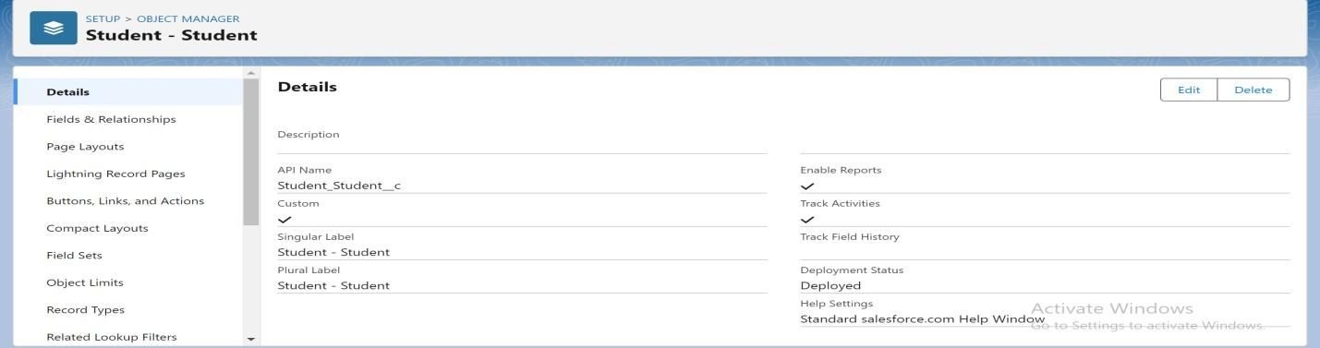

**Fig.1.2.3 Student Object**

## **1.3 RELATIONSHIP AMONG OBJECTS**

We created lookup relationships between the Appointment object and the Student and Consultant objects. This allows each appointment to be associated with a specific student and linked to a specific consultant, facilitating efficient appointment tracking and management.

**Lookup Relationship:** Appointment to Student

* Go to Setup > Object Manager and select the Appointment object.
* Click Fields & Relationships > New.
* Select Lookup Relationship and choose Student as the related object.
* Enter a suitable Field Label and Field Name
* Set the field-level security and page layout visibility.
* Review the configuration and click Save.

**LookUp Relationship:** Appointment to Consultant

* Go to Setup > Object Manager and select the Appointment object.
* Click Fields & Relationships > New.
* Select Lookup Relationship and choose Consultant as the related object.
* Enter a suitable Field Label and Field Name
* Set the field-level security and page layout visibility.
* Review the configuration and click Save.

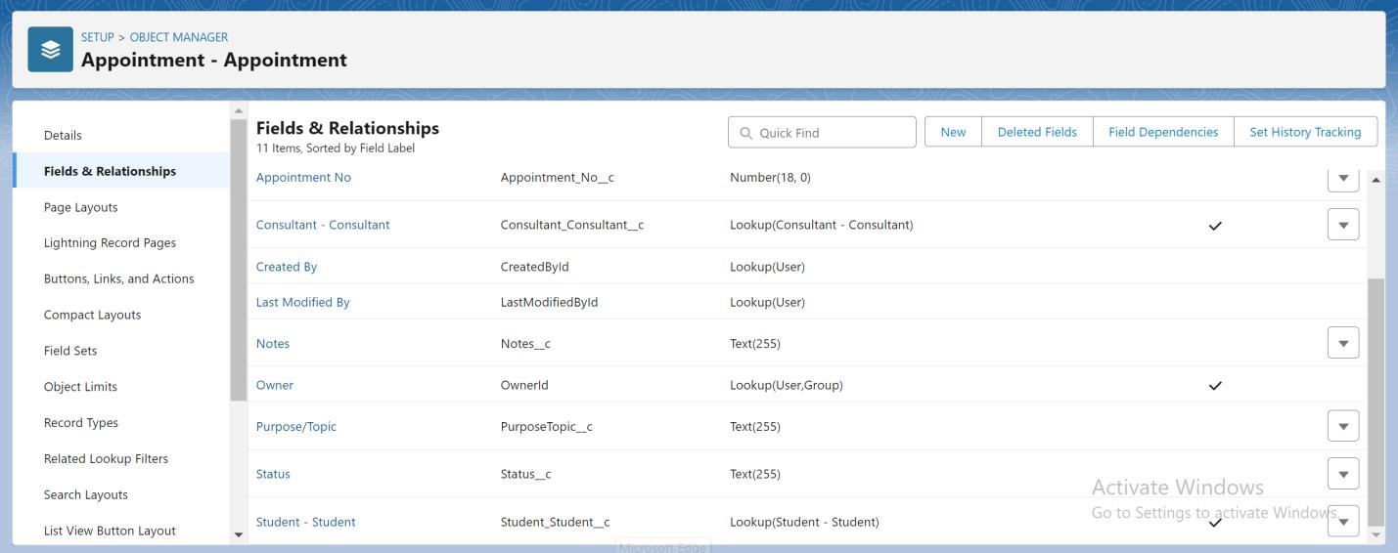

**Fig.1.3.1 Appointment Object After Creating Lookup Relationships**

## **Registration Object Creation**

* Go to Setup in Salesforce and select Object Manager**.**
* Click on Create > Custom Object, then enter

Label:Registration,

Plural Label:Registrations.

* Set the Object Name to Registration and enable Allow Reports and Track Activities as needed.
* Add lookup relationships with Student and Consultant objects to link each registration to a specific student and consultant.

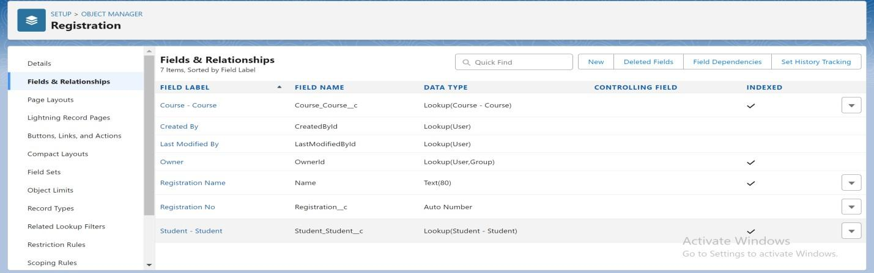

**Fig.1.3.2 Registration Object**

## **LookUp Relationship**: Student to Case

* Go to Setup > Object Manager and select the Student object.
* Click Fields & Relationships > New.
* Select Lookup Relationship and choose Case as the related object.
* Enter a suitable Field Label and Field Name
* Set the field-level security and page layout visibility.
* Review the configuration and click Save.

## **Create Tabs**

* Go to Setup > Tabs > New Custom Object Tabsand select the appropriate object.
* Choose a suitable Tab Styleand label, then review and click Save to finalize the creation.

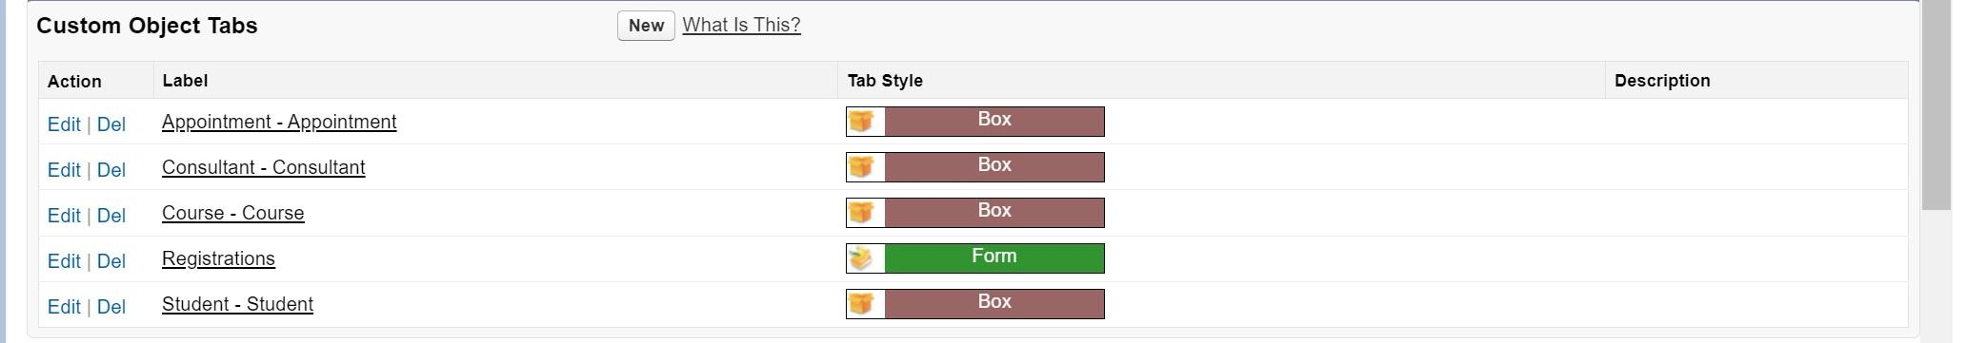

**Fig.1.3.3 Custom Object Tabs**

## **1.4 CONFIGURE CASE OBJECT**

* Navigate to Setup > Object Manager > Case and select the Case object for editing.
* Under Fields & Relationships, find the "Type" field and add the values "Immigration" and "Visa Application."
* Next, locate the "Status" field and add the values "Open" and "In-progress" to reflect the query progress.

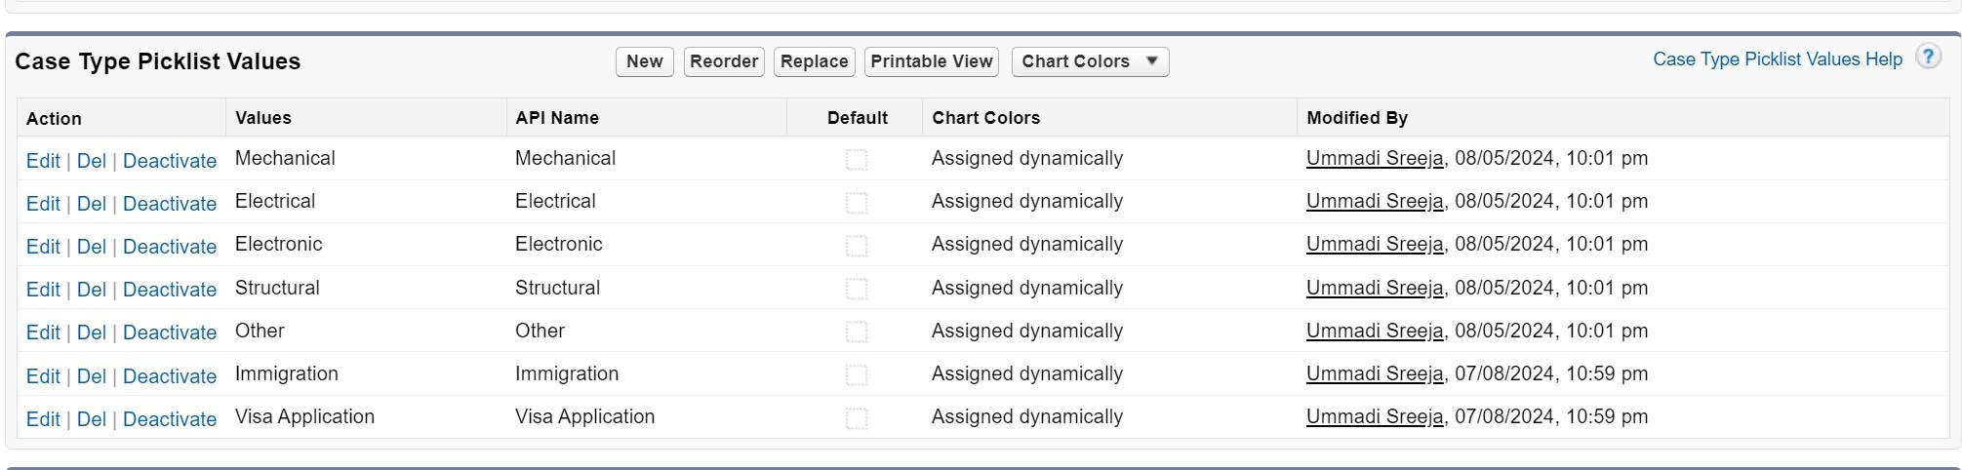

**Fig.1.4.1 Case Object Configuration**

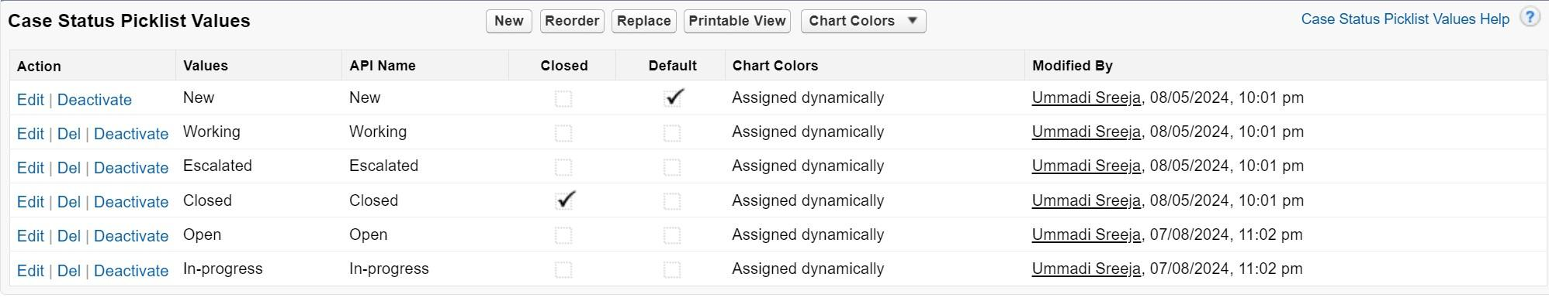

**Fig.1.4.2 Case Object Configuration**

## **1.5 LIGHTNING APP CREATION**

* Go to Setup and search for "App Manager" in the Quick Find box.
* Click on New Lightning App and name it “EduConsultPro,” then click Next through the setup screens.
* Add Home, Students, Courses, Consultants, Appointments, Registrations, and Cases to

Selected Items.

* Select "System Administrator" from Available Profiles and move it to Selected Profiles, then click Save & Finish.

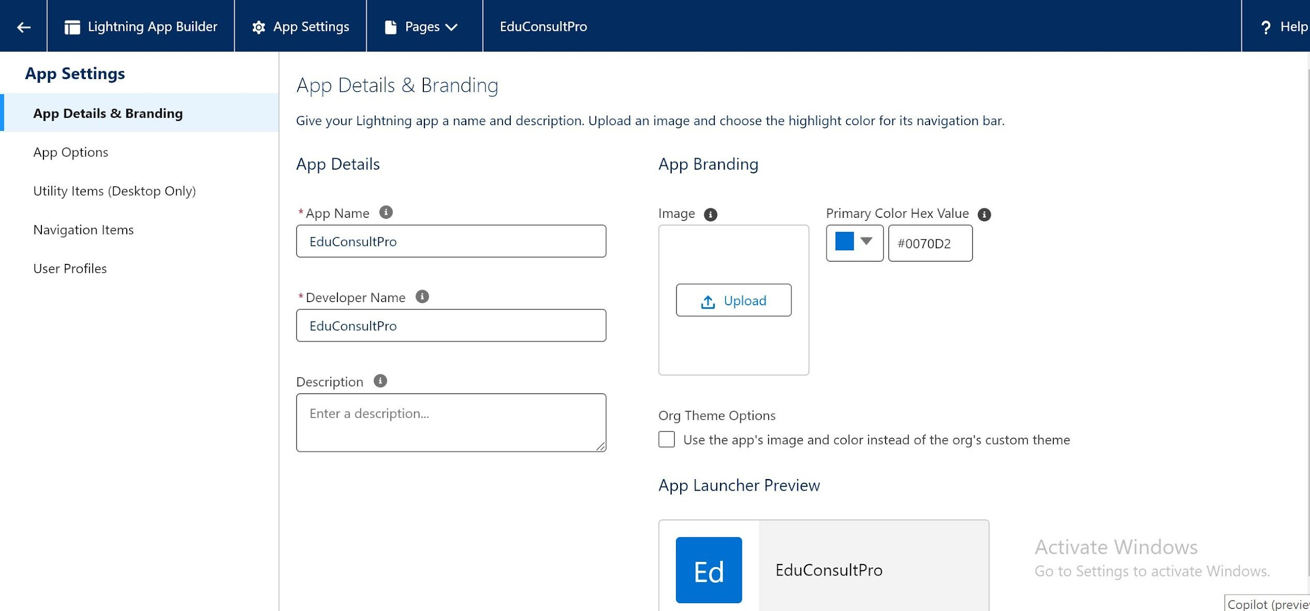

**Fig.1.5.1 EduConsultPro Lightning App**

# **TASK 2**

**CREATE STUDENT ADMISSION FLOW**

To automate and streamline the student admission process at EduConsultPro, a custom flow was created in Salesforce. This flow guides the admissions staff through a series of steps, including gathering student information, making decisions based on application criteria, and automating communication via email. By integrating screen elements, record creation, decision logic, and email actions, the flow ensures a seamless and efficient experience for both staff and prospective students.

## **2.1 ADD SCREEN ELEMENT**

* Go to Setup and search for "Flow Builder" in Quick Find, then select New Flow and choose Screen Flow.
* Add a Screen element and set the Label to “Student Info” in the Screen Properties pane.
* Create a new resource (StudentRecordRes) for the record variable input, and drag the necessary fields from the Student object onto the screen to collect student information.

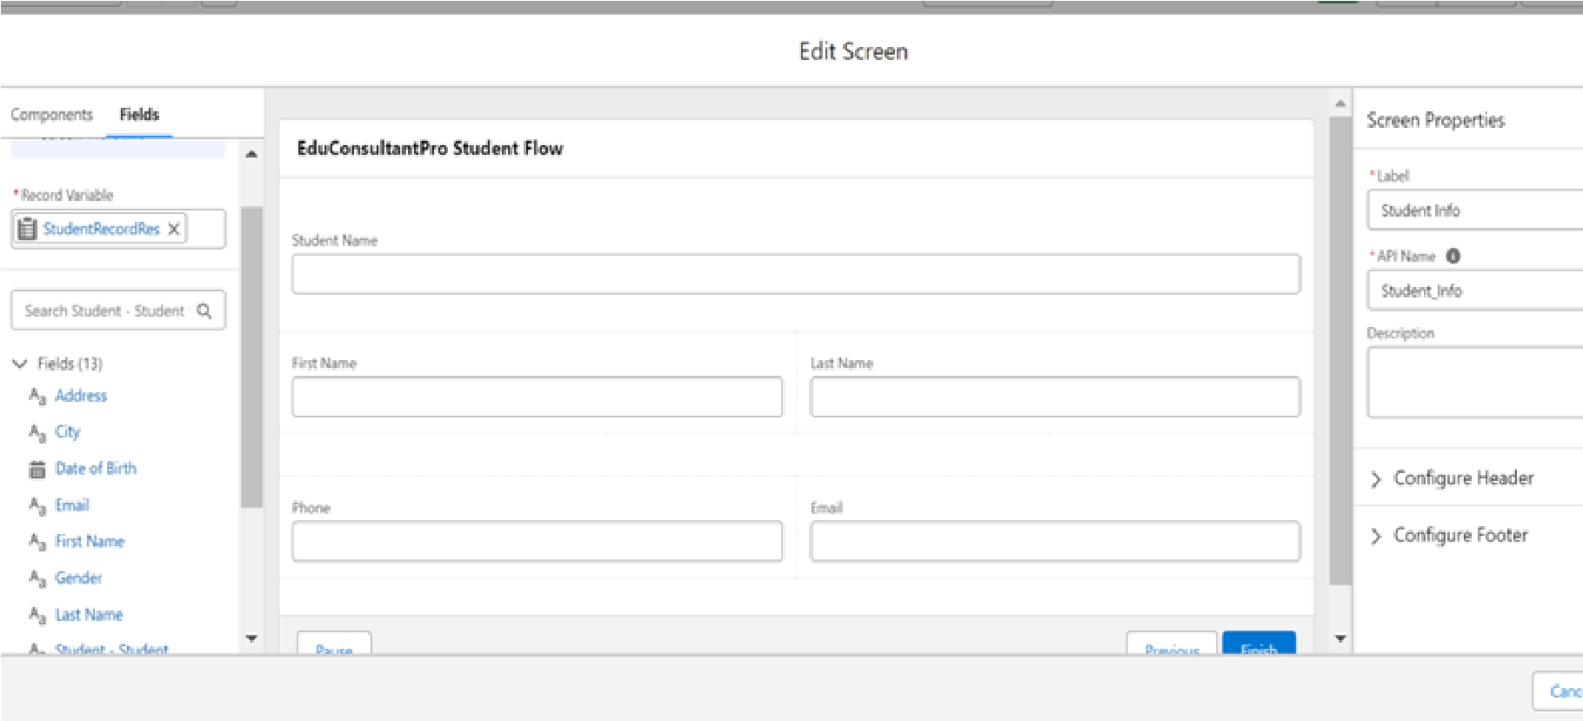

**Fig.2.1.1 Student Info Screen Flow**

## **2.2 CREATE RECORDS**

* Add a Create element after the Student Info Screen Element and label it as “Create Student Record.”
* Select "One" for How many records to create and choose "Use all values from a record"

for setting the record fields.

* Choose the StudentRecordRes resource created earlier in the Student Info screen to populate the new student record.

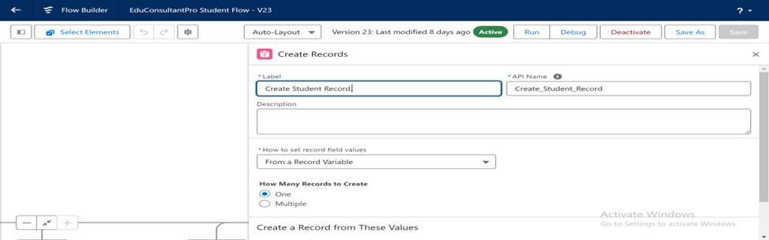

**Fig.2.2.1 Create Student Record**

* Add a Screen element after the Create Student Record element and label it as “Course Screen.”
* Add a picklist component labeled “Select Course” and create choices for "IELTS," "GRE," "GMAT," "Duolingo," and "TOEFL."

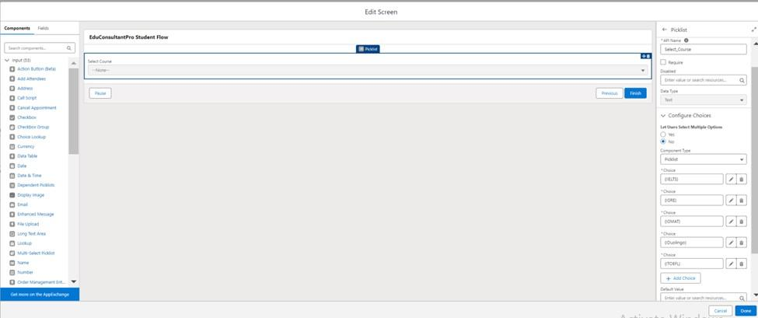

**Fig.2.2.2 Select Course Screen Flow**

## **2.3 ADD DECISION ELEMENT**

* Add a Decision element after the Course Screen element and label it as “Selecting Course.”
* For the first outcome, label it as “Selected IELTS” and set the condition: Resource = Select_Course, Operator = Equals, Value = IELTS.

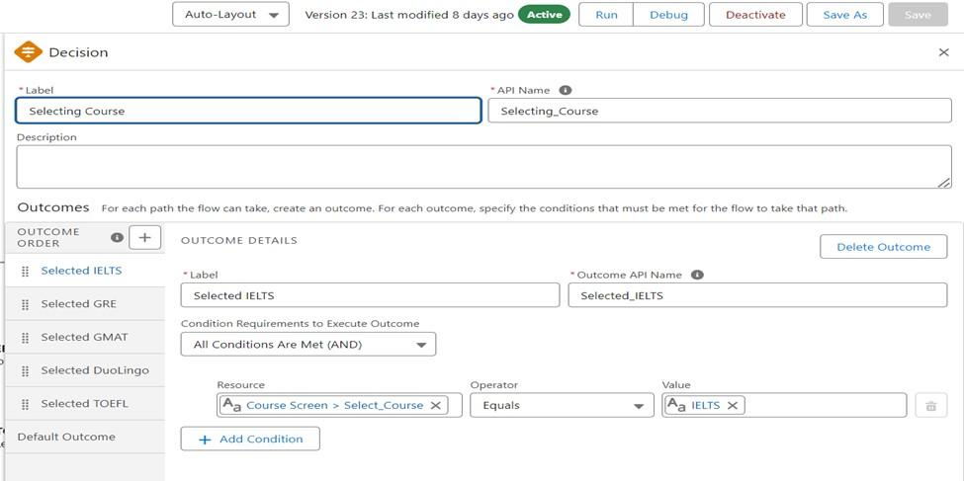

**Fig.2.3.1 Select Course Decision Element**

* Click the “+” icon to add additional outcomes for "GRE," "GMAT," "Duolingo," and "TOEFL" using the same condition format.
* Click Done to save the Decision element configuration.

## **2.4 ADD GETRECORD ELEMENT**

* Add a Get Record element after the Decision element under the IELTS path and label it as “Get IELTS Rec.”
* Set the Object to Course with the condition: Field = Course Name, Operator = Equals,

Value = {!Select_Course}, ensuring that all conditions are met (AND).

* Repeat the steps 1 & 2 for the GRE, GMAT, TOEFL, DuoLingo paths.

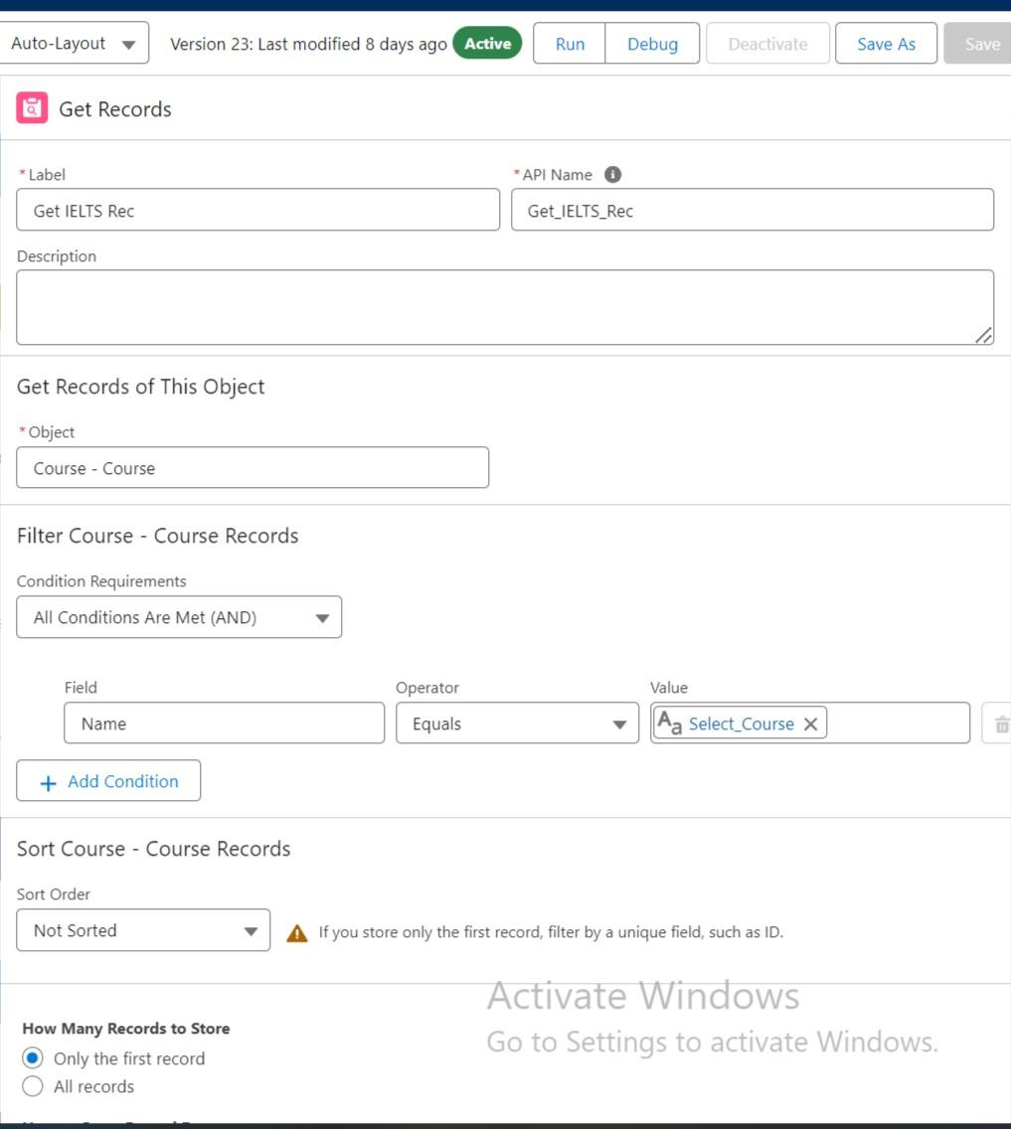

**Fig.2.4.1 GetRecord Element**

* Add a Create Records element after the Get IELTS Rec element and label it as “Create IELTS Registration Rec.” Set it to create "one" record using "Use separate resources, and literal values."
* Select Object: Registration and set the fields: Course_Name__c = {!Get_IELTS_Rec.Id} and Student_Name__c = {!StudentRecordRes.Id}.
* Repeat this process for the GRE, GMAT, TOEFL, and Duolingo paths, creating respective registration records.

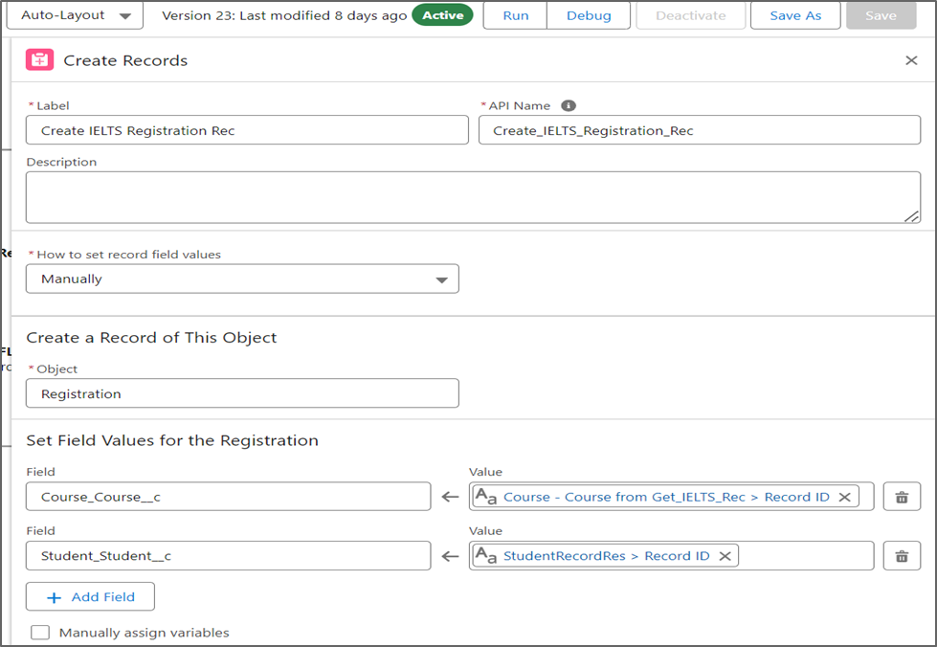

**Fig.2.4.2 Creating registration records for selected courses based on student information**

## **2.5 CREATE EMAIL TEMPLATE**

* Click on the toggle toolbox in the left corner, select “New Resource,” and choose "Text Template" as the Resource Type.
* Name the API as “StuRegistrationEmailTextTempBody,” select "View as plain text," and paste the provided email body text.
* Click Done to save the email text template.

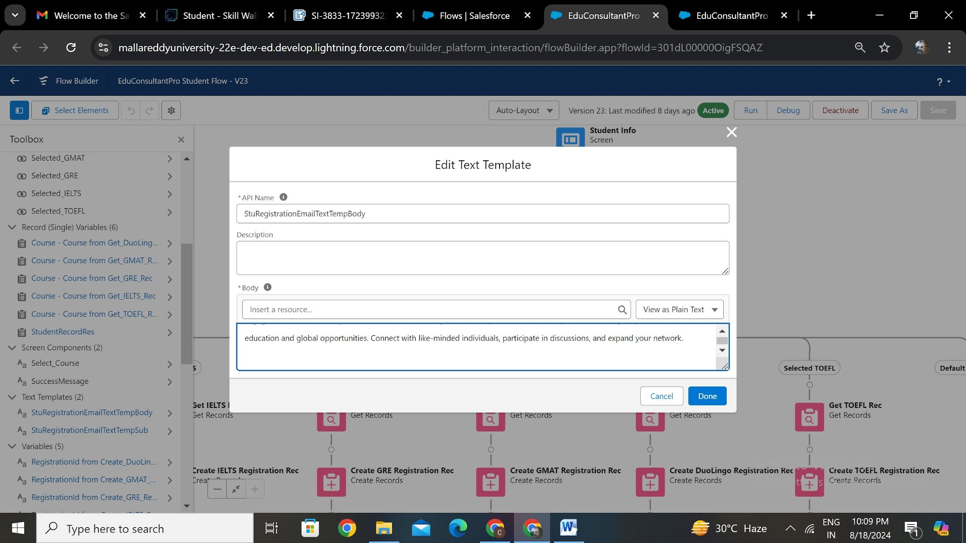

**Fig 2.5.1 Email Template**

## **2.6 ADD ACTION ELEMENT**

* Add an Action element after all the Decision paths and label it as “Send Email to Student.”
* In "Set input values for selected action," set the Body to

{!StuRegistrationEmailTextTempBody}, Recipient Address List to

{!StudentRecordRes.Email__c}, and Subject to {!StuRegistrationEmailTextTempSub}.

* Click Done to finalize the email action setup.

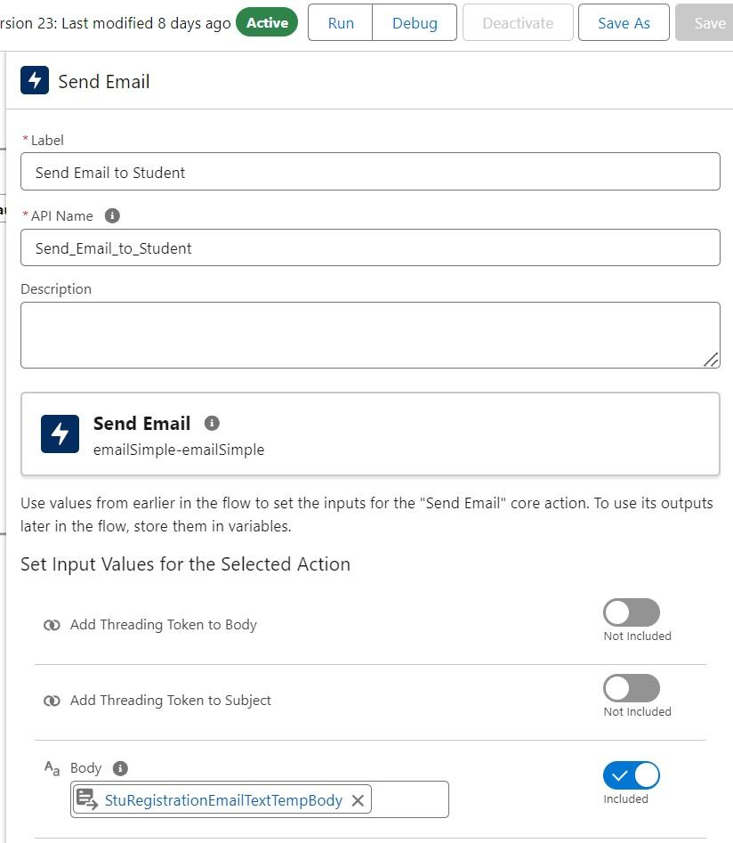

**Fig 2.6.1 Send Email Action Element**

* Add a Screen element after the Send Email to Student Action element and label it as “Success Screen.”
* Drag a Display Text component into the main panel, label it “SuccessMessage,” and paste the provided text into the Resource picker box.
* Click Done, save the flow, and name it “EduConsultPro Student Flow.”

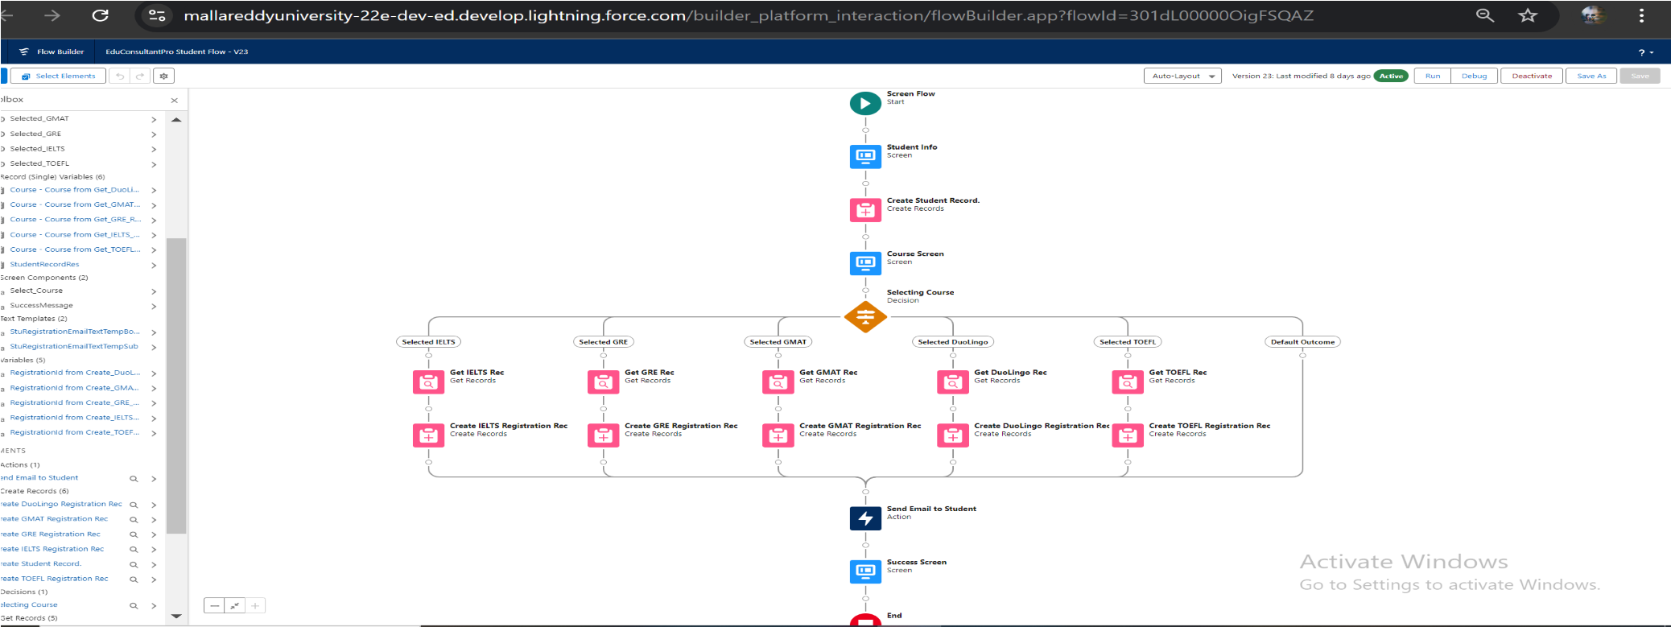

**Fig 2.6.2 EduConsultPro Student Flow**

# **TASK 3**

# **CREATE USERS**

To ensure that consultants can effectively use the EduConsultPro platform, a new user with the appropriate permissions and access is created. This user will have the Standard Platform User profile, granting them access to essential features required for their role.

## **3.1 CREATE USER**

* Go to Setup > Administration > Users and click on New User.
* Enter Last Name as “Consultant,” select License as "Salesforce Platform," and choose Profile as "Standard Platform User."
* Fill in all mandatory fields .
* Click Save to create the new user.

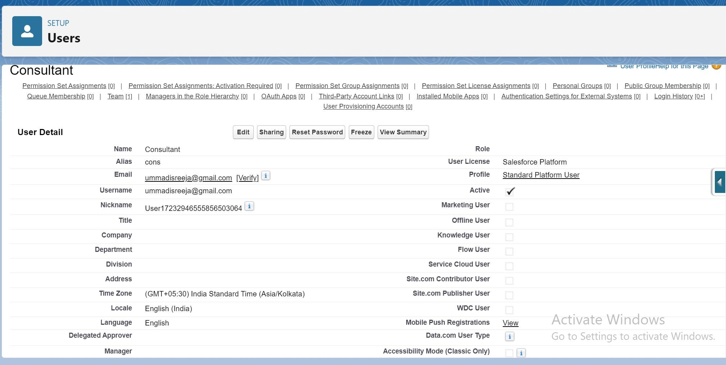

**Fig 3.1.1 Creating New User**

## **3.2 CONFIGURE SETTINGS**

* Go to Setup --> Administration --> Users --> click Edit next to your name
* Scroll down to bottom, under Approver Settings, Select “Consultant” the Manager Field.
* Click Save.

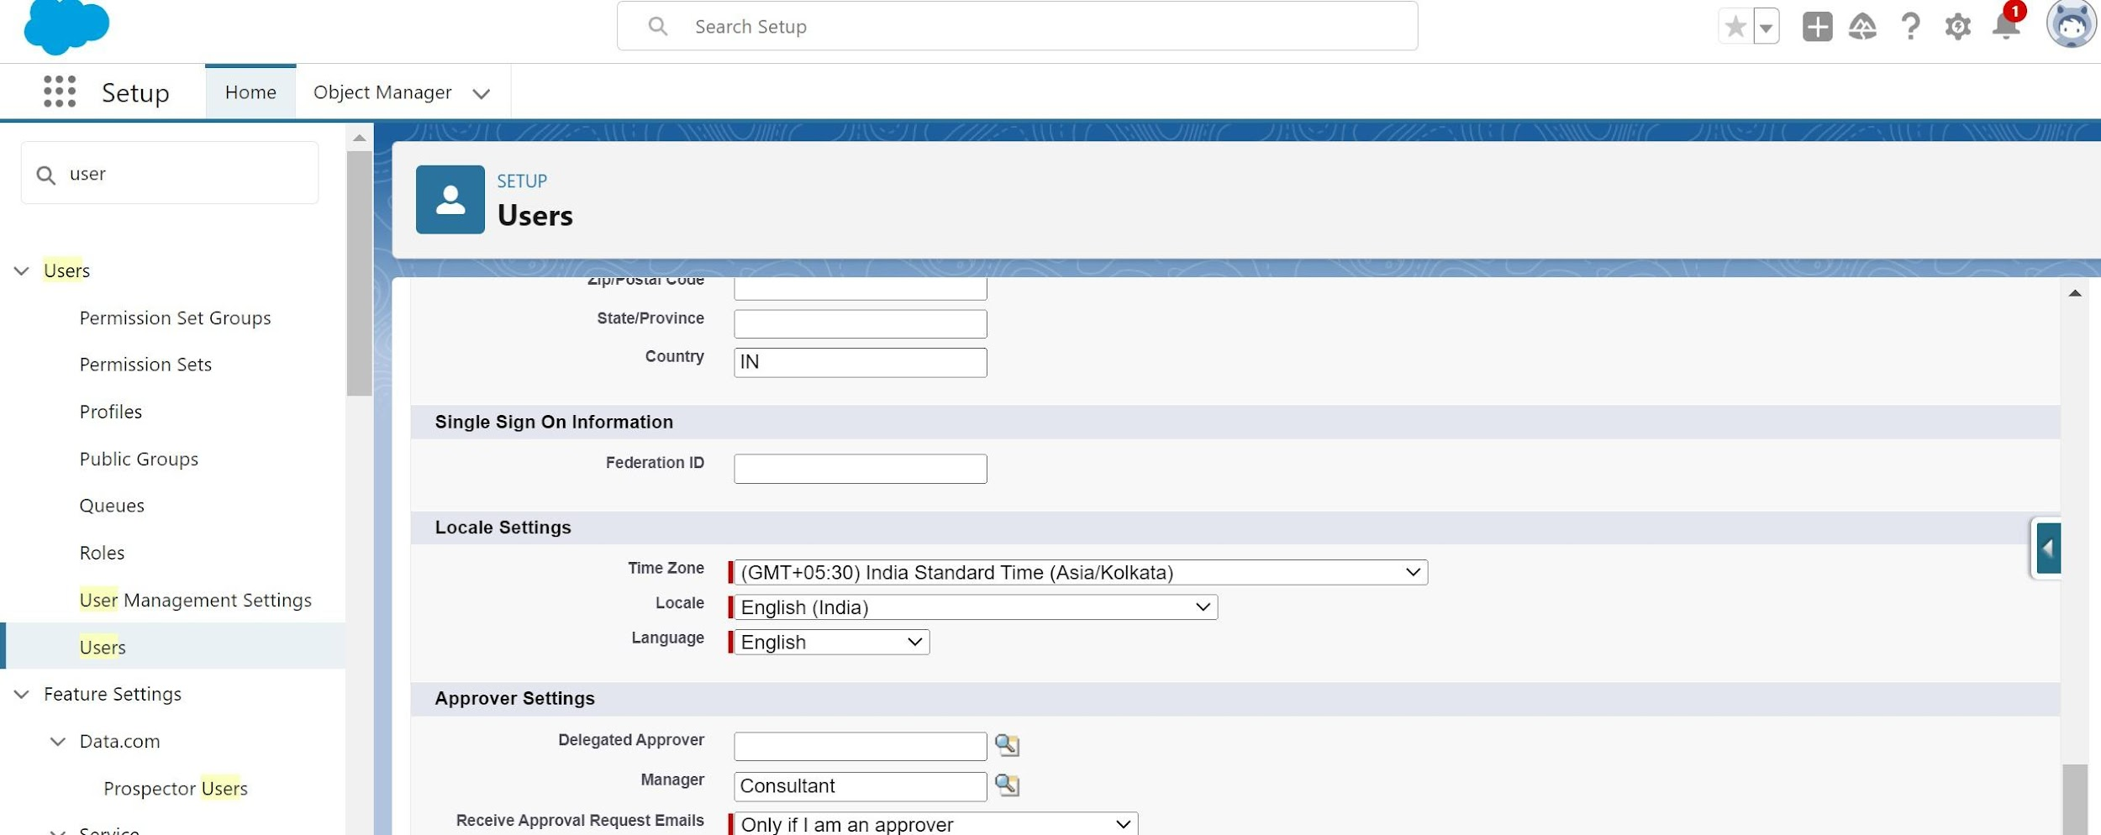

**Fig 3.2.1 User Configuration**

# **TASK 4**

# **CREATE APPROVAL PROCESS**

To effectively manage and track student appointment requests, an approval process was established within Salesforce. This process ensures that all appointment requests are reviewed and either approved or rejected based on predefined criteria. By automating these steps, the system enhances operational efficiency and maintains consistency in handling student appointments.

## **4.1 CREATE APPROVAL PROCESS**

* Go to Setup > Templates and select “Lightning Email Templates” to toggle it on, then use the App Launcher to create a new folder for email templates.
* Create a new email template within the folder, enter the provided HTML content, and save it as "Submission Template."

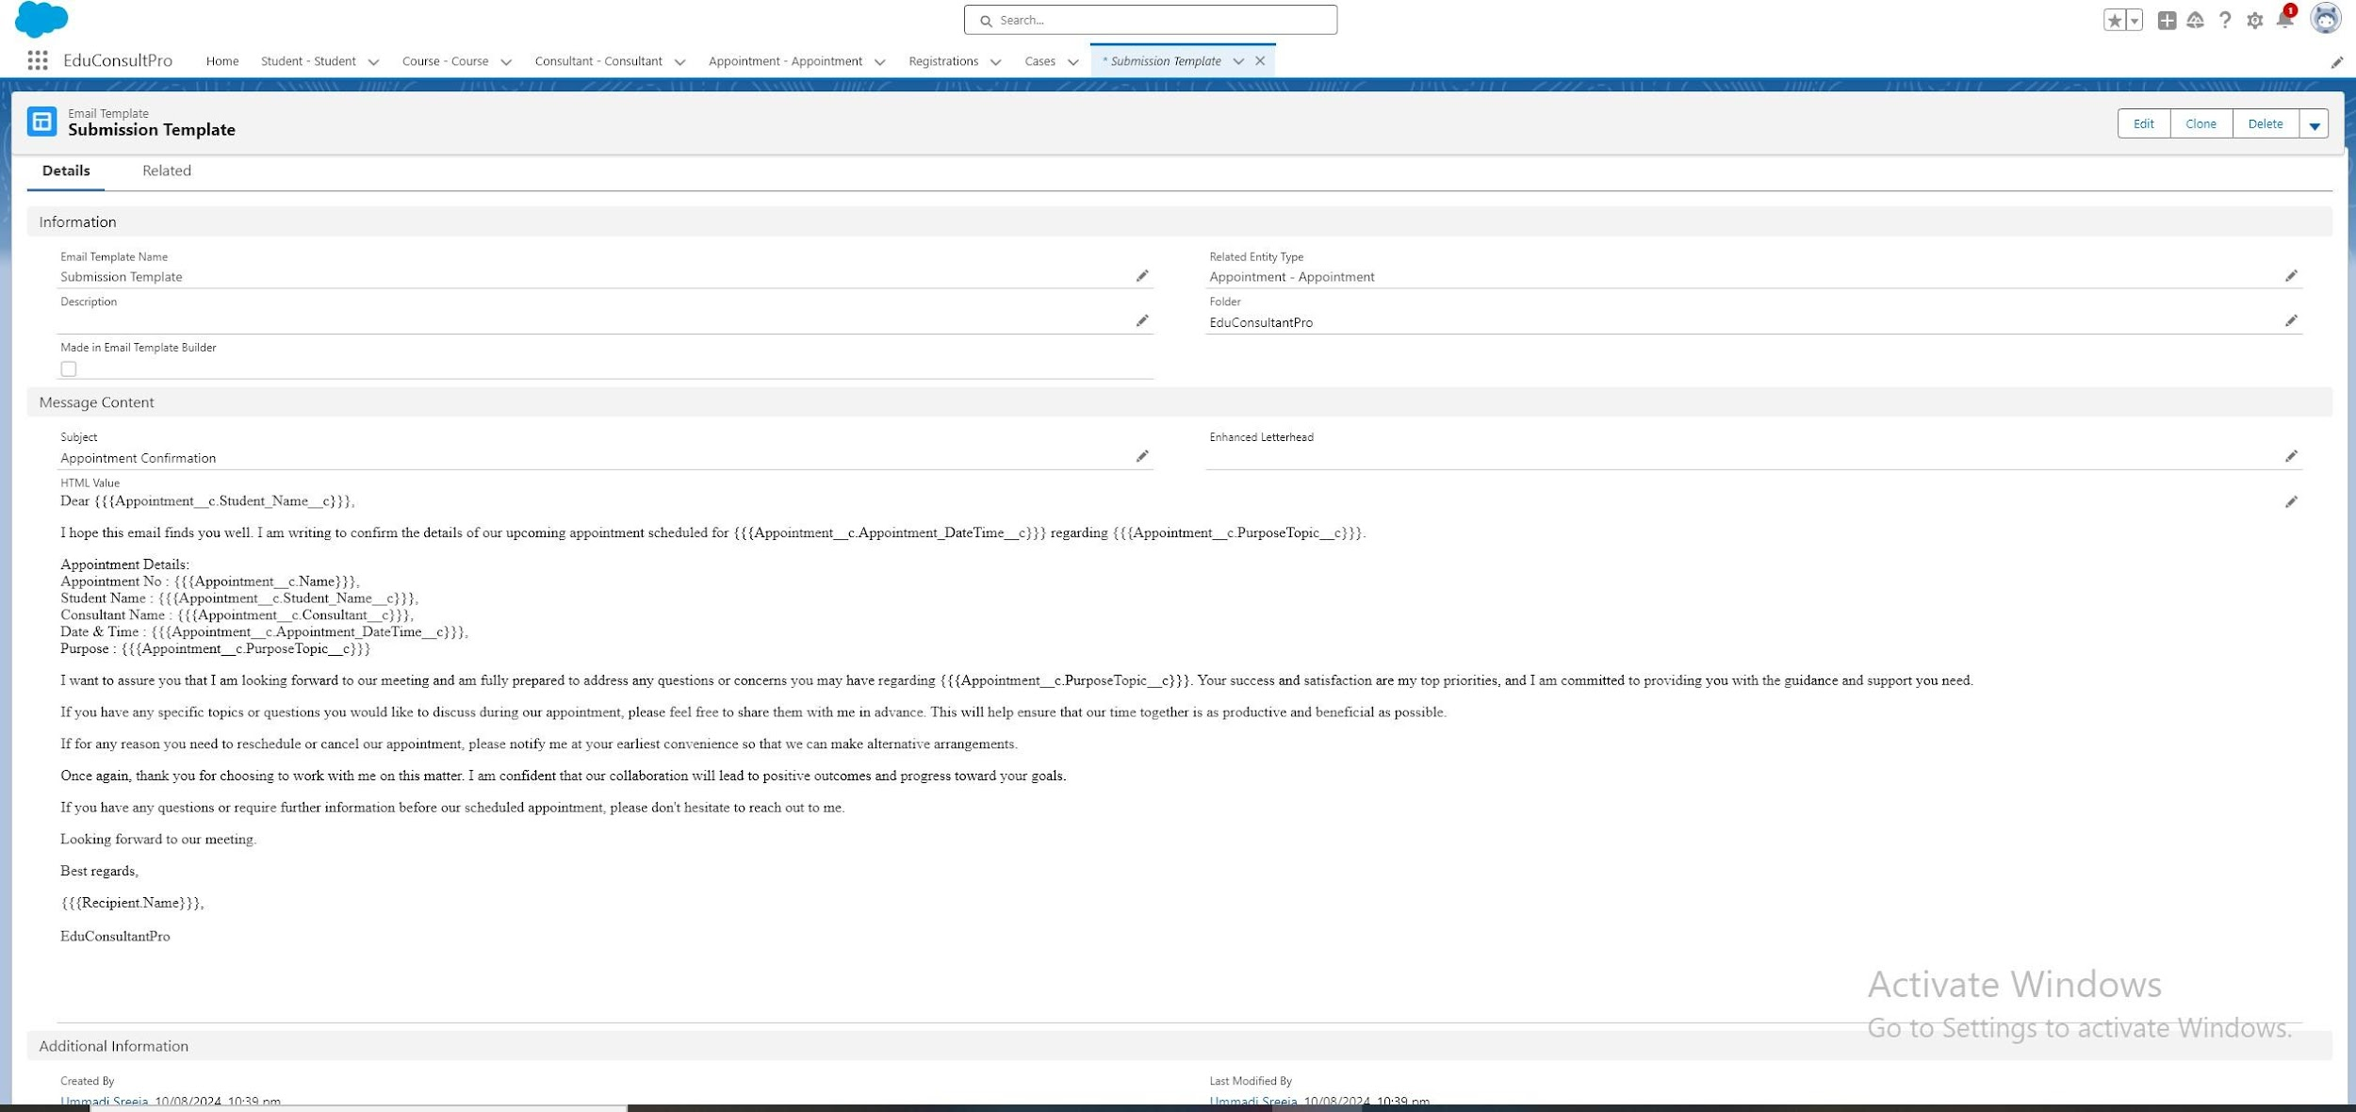

**Fig 4.1.1 Submission Template**

* Create a new email template within the folder, enter the provided HTML content, and save it as "Approval Template".

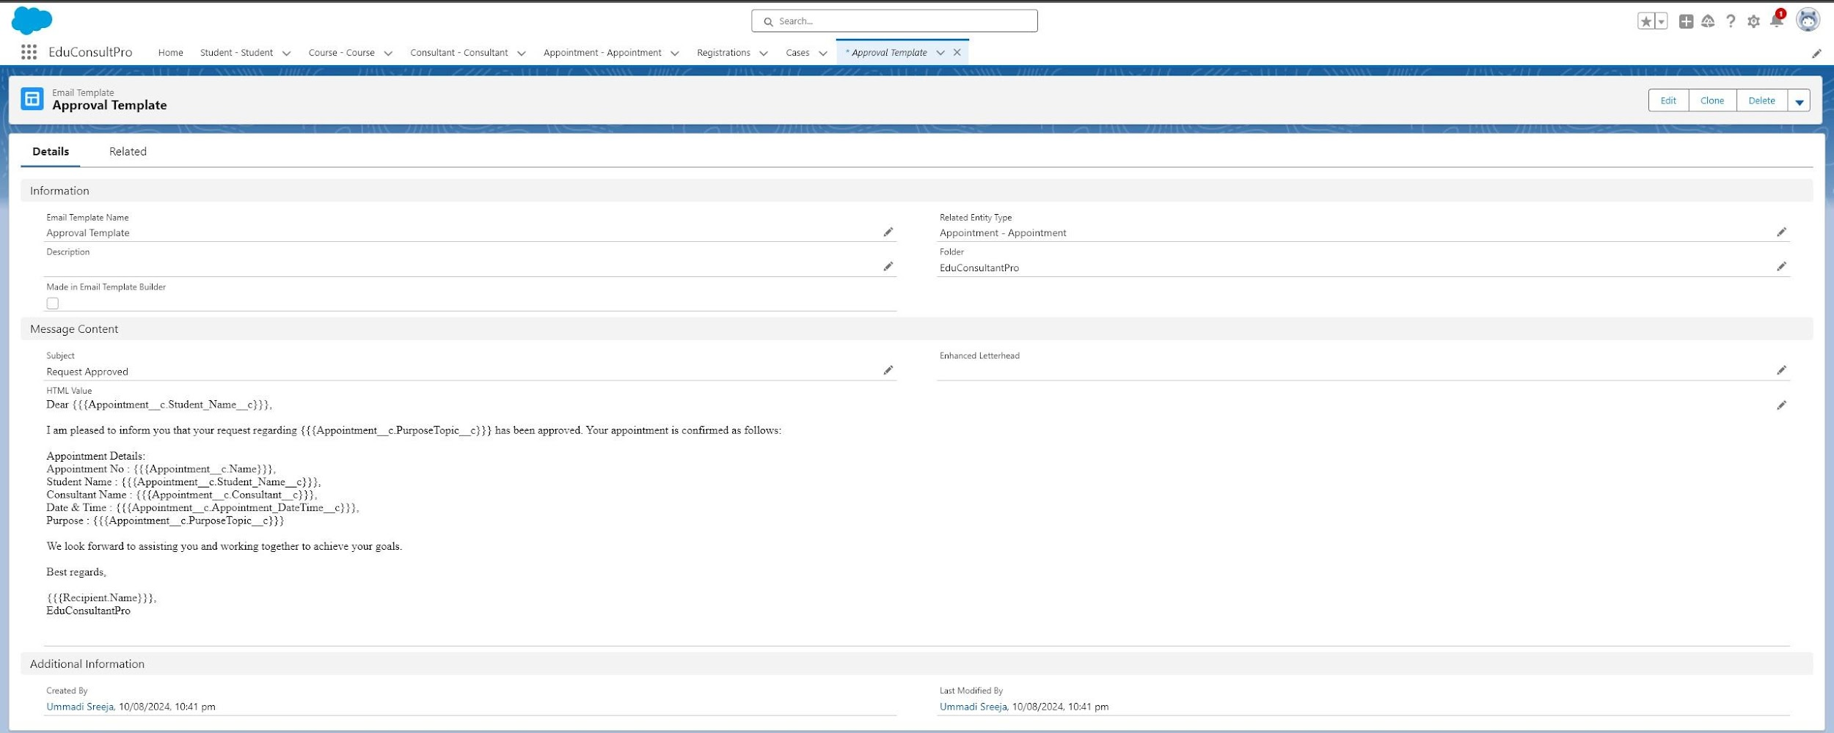

**Fig 4.1.2 Approval Template**

* Create a new email template within the folder, enter the provided HTML content, and save it as "Rejection Template".

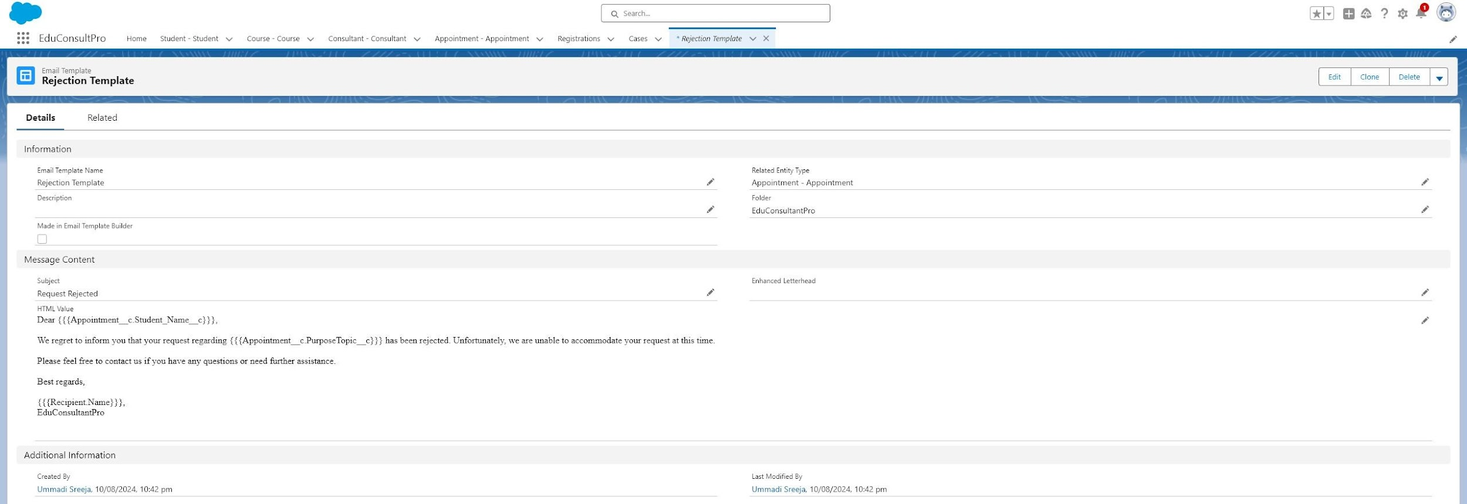

**Fig 4.1.3 Rejection Template**

## **4.2 CREATE APPROVAL PROCESS**

* Go to Setup, search for "Approval Processes," and select Appointment.
* Create a new approval process using the Jump Start Wizard, name it “Appointment Approval,” and set the approver to Manager using a standard or custom hierarchy field.
* Configure Record Editability Properties to allow Administrators or the current approver to edit records during the approval process and save it.
* Add Initial Submission Actions: Field Update with Name “Submitted,” Field to Update “Appointment: Status,” and Value “Pending.”
* Add an Email Alert with Description “Submission Email Alert,” Email Template

“Submission Template,” and Recipient Type set to your name.

* Add Final Approval and Final Rejection actions.

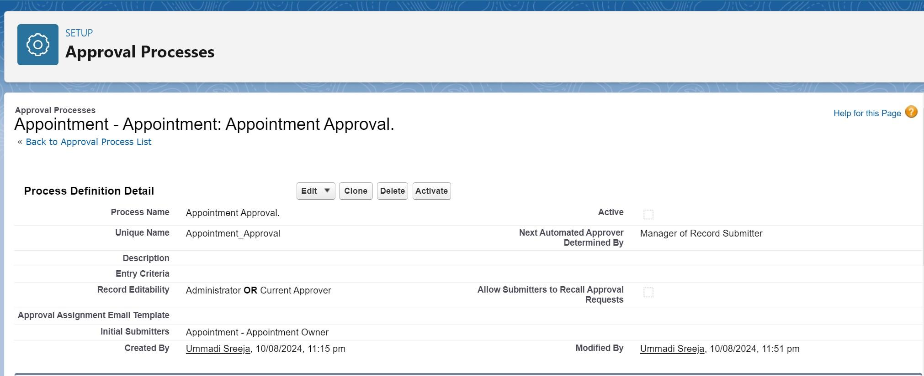

**Fig.4.2.1 Appointment Approval Process**

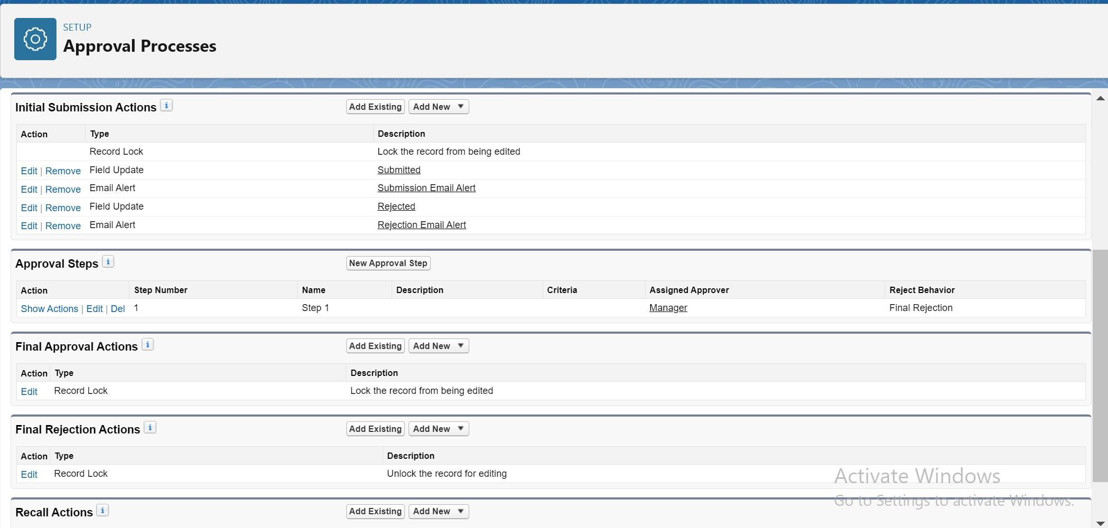

**Fig.4.2.1. Approval Process Actions**

# **TASK 5**

# **CREATE RECORD TRIGGERED FLOW**

To automate the approval process for student appointments, a Record-Triggered Flow is configured in Salesforce. This flow starts when a new appointment record is created and triggers the approval process seamlessly.

## **5.1 CONFIGURE STRAT ELEMENT**

* Go to Setup, search for "Flows," and select New Flow.
* Choose Record-Triggered Flow and click Create. In the Configure Start window, select Appointment for Object and set the Trigger the Flow When option to “A record is created.”

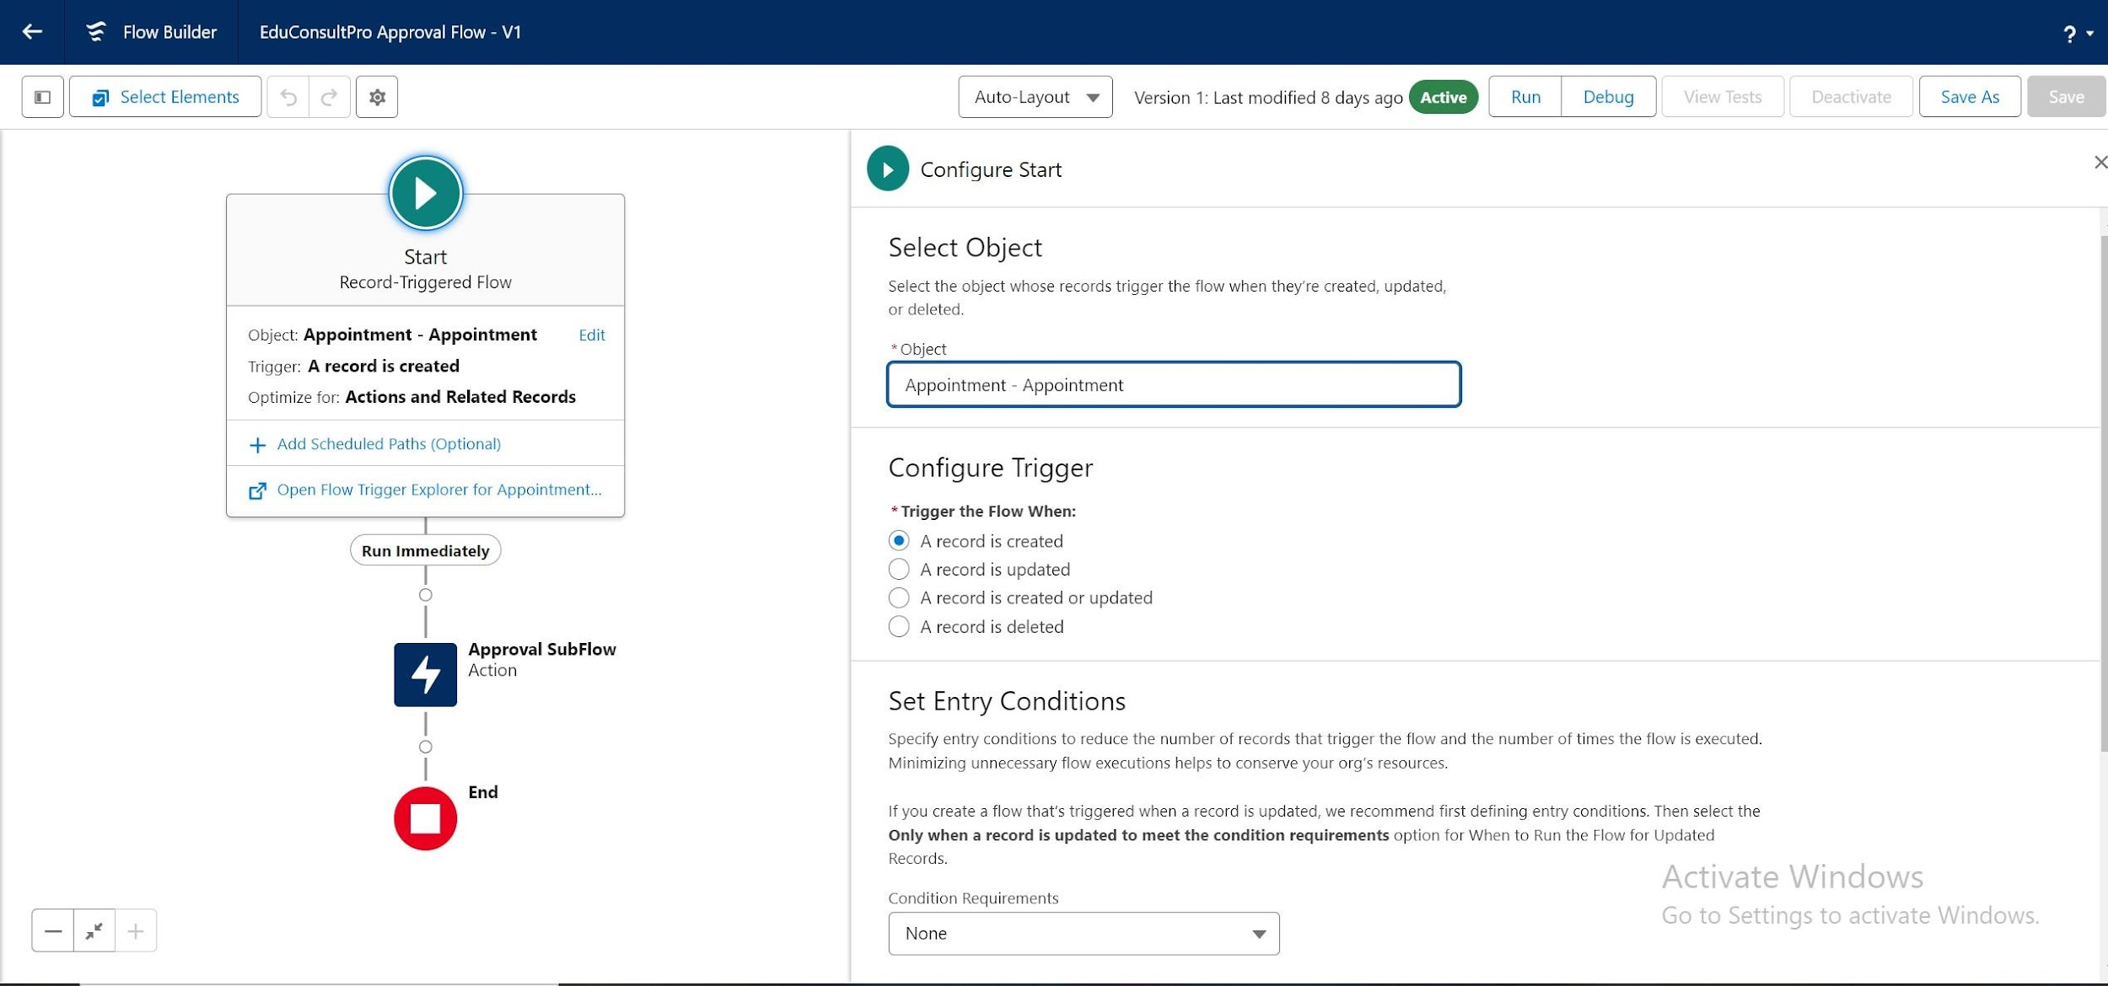

**Fig.5.1.1 Configure Record Triggered Flow**

## **5.2 ADD ACTION ELEMENT**

* Add an Action element after the Start Element, and select the “Submit for Approval” action, labeling it as “Approval SubFlow.”
* Set the RecordId to “{!$Record.Id}” to reference the current appointment record.

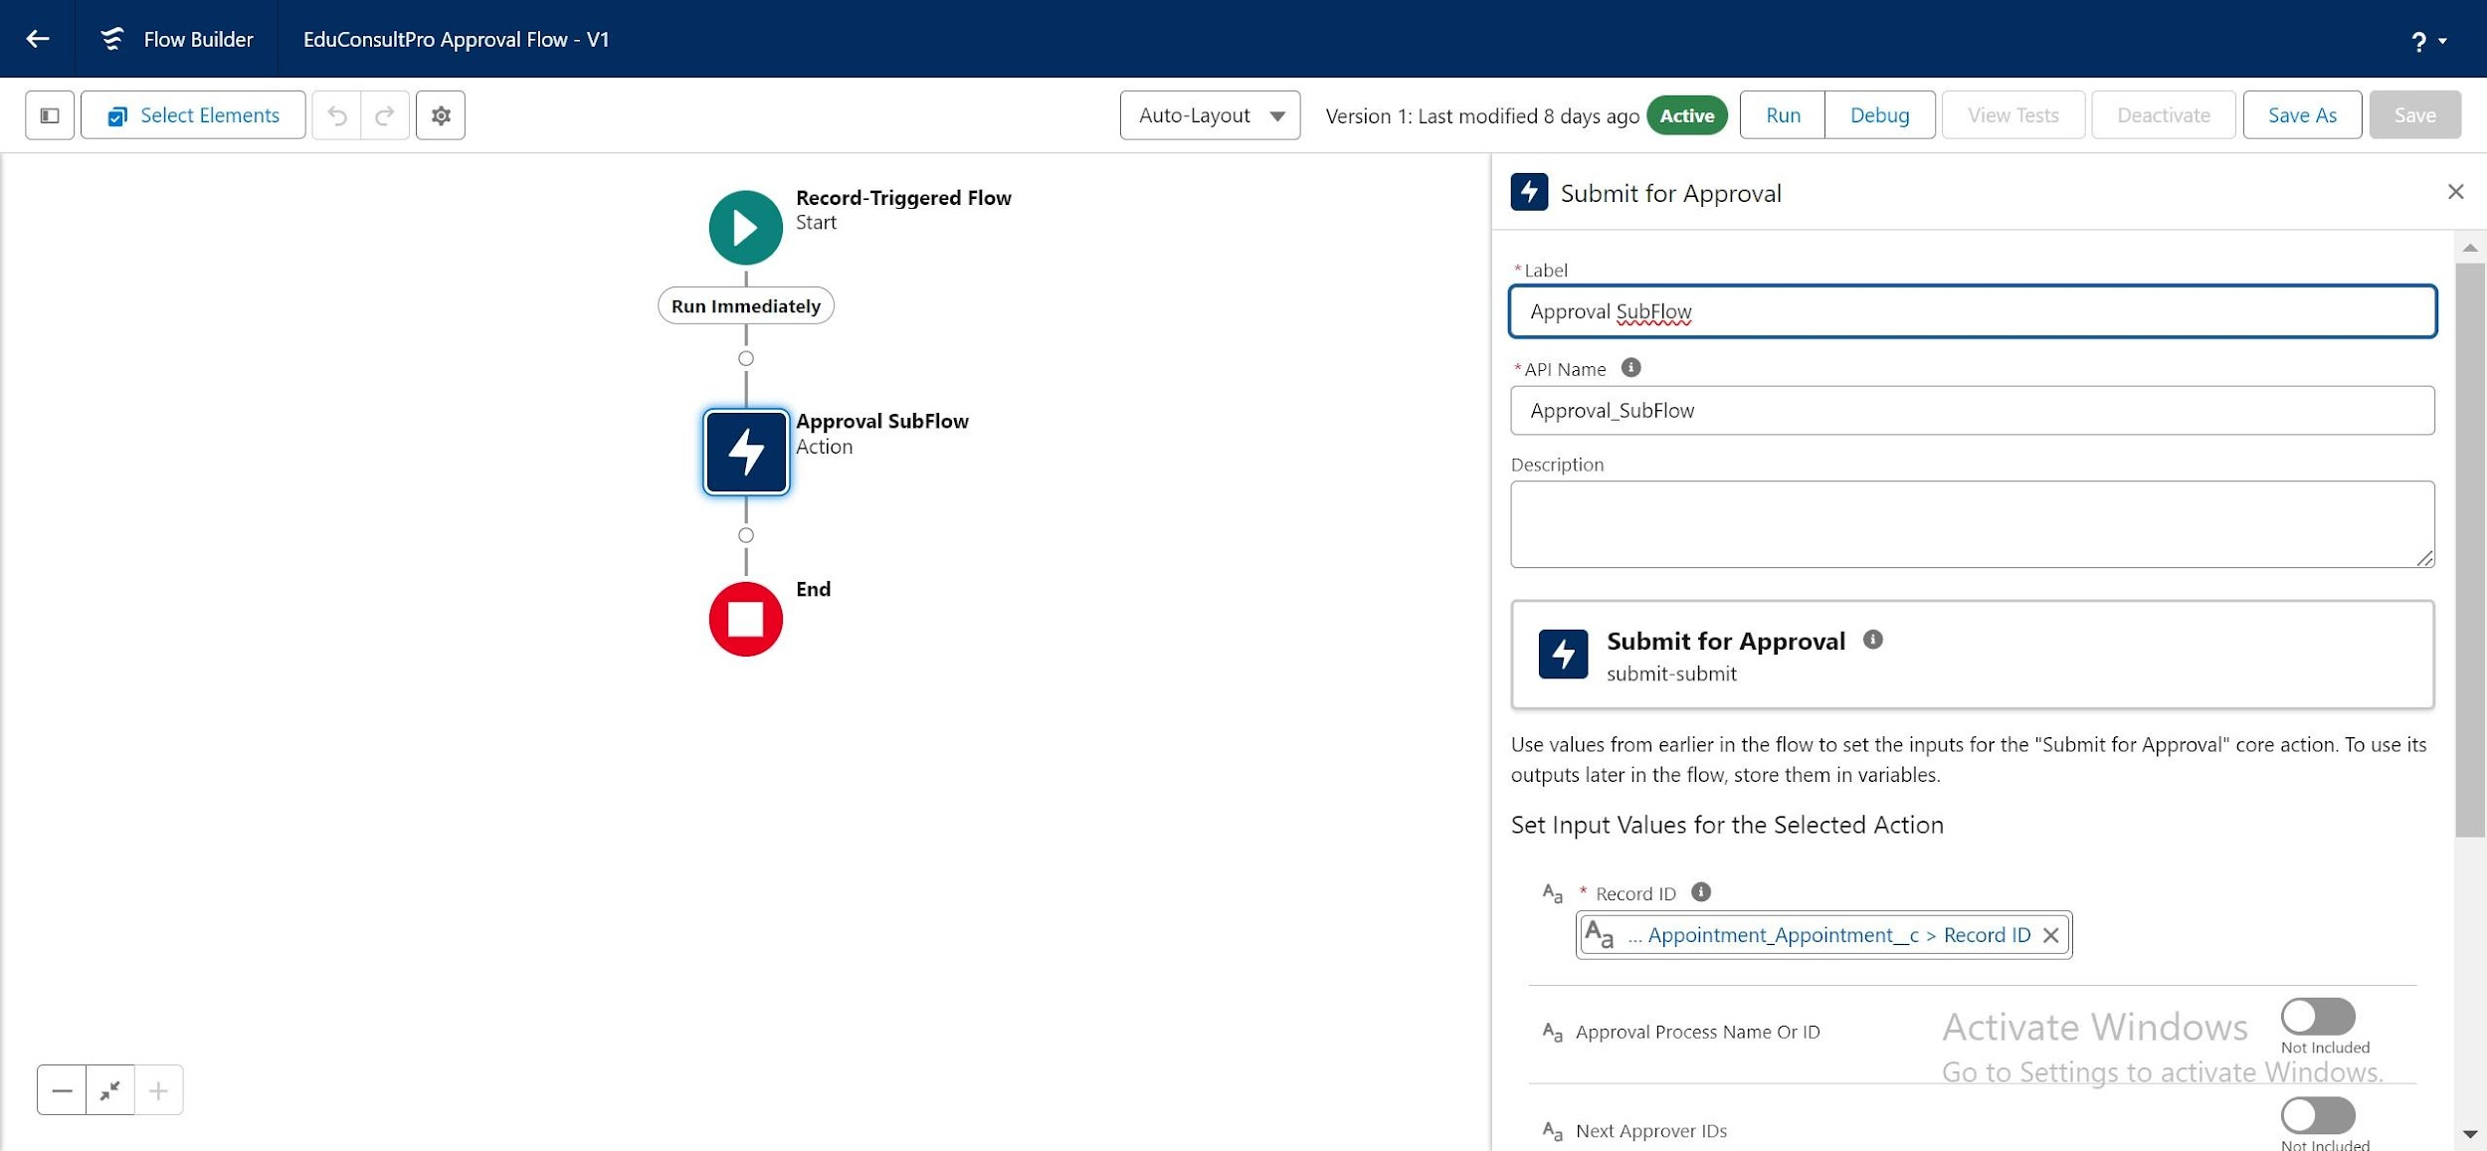

**Fig 5.2.1 Approval Subflow Action Element**

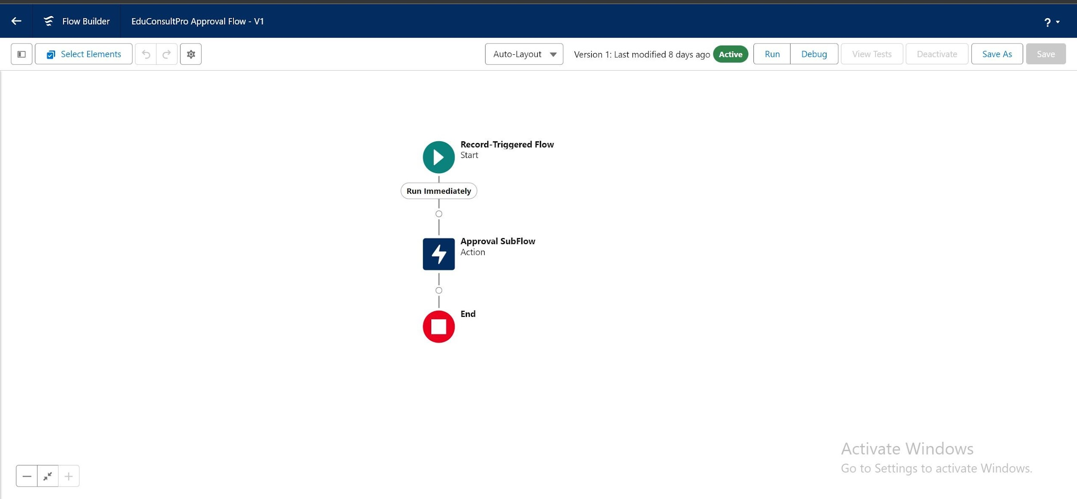

**Fig .5.2.3 EduConsultPro Approval Flow**

**TASK 6**

**CREATE APPOINTMENT BOOKING FLOW**

To facilitate the appointment booking process for existing students at EduConsultantPro, we will create a ScreenFlow in Salesforce. This flow will guide students through entering their details, selecting an appointment, and confirming their booking. Additionally, it provides an option to create a case if the student has specific concerns or queries.

## **6.1 ADD SCREEN ELEMENT**

* Go to Setup, enter Flow Builder in the Quick Find box, and select "New Flow" > ScreenFlow.
* Add a Screen element and label it “Get Student Info.”
* Add two Text components for student details:
  1. Label the first Text component as "Enter Student Name."
  2. Label the second Text component as "Enter Student Email."

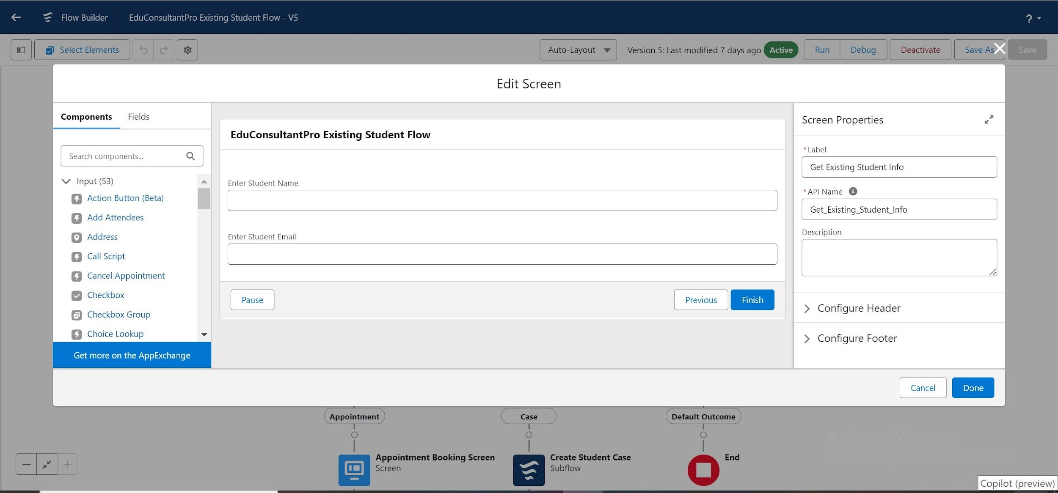

**Fig.6.1.1 Get Existing Student Info Screen Element**

### **6.2 ADD GET RECORD ELEMENTS**

* Add a GET Record Element after the Screen Element, label it “Get Rec.”
* Set the Object to Student and apply the following conditions:
  1. Field: Student Name, Operator: Equals, Value: {!Enter_Student_Name}.
  2. Field: Email__c, Operator: Equals, Value: {!Enter_Student_Email}.

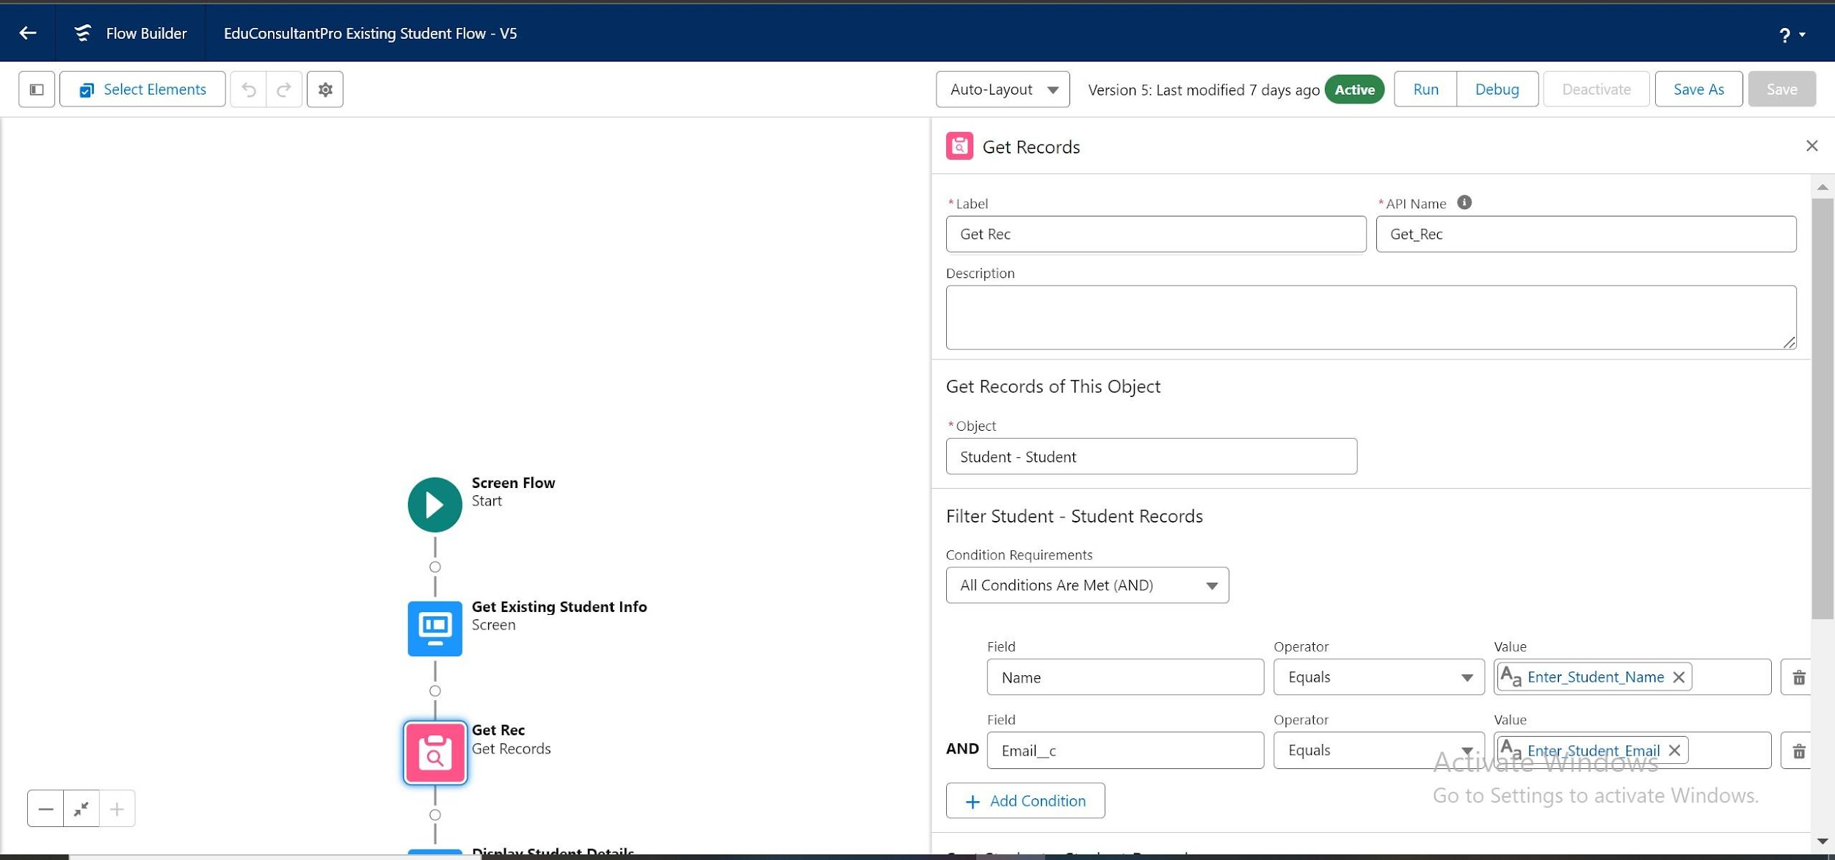

**Fig.6.2.1 Get Record Element**

## **6.3 ADD DECISION ELEMENT**

* Add a Decision Element after the Display Student Details Element, label it “Appointment or Case.”

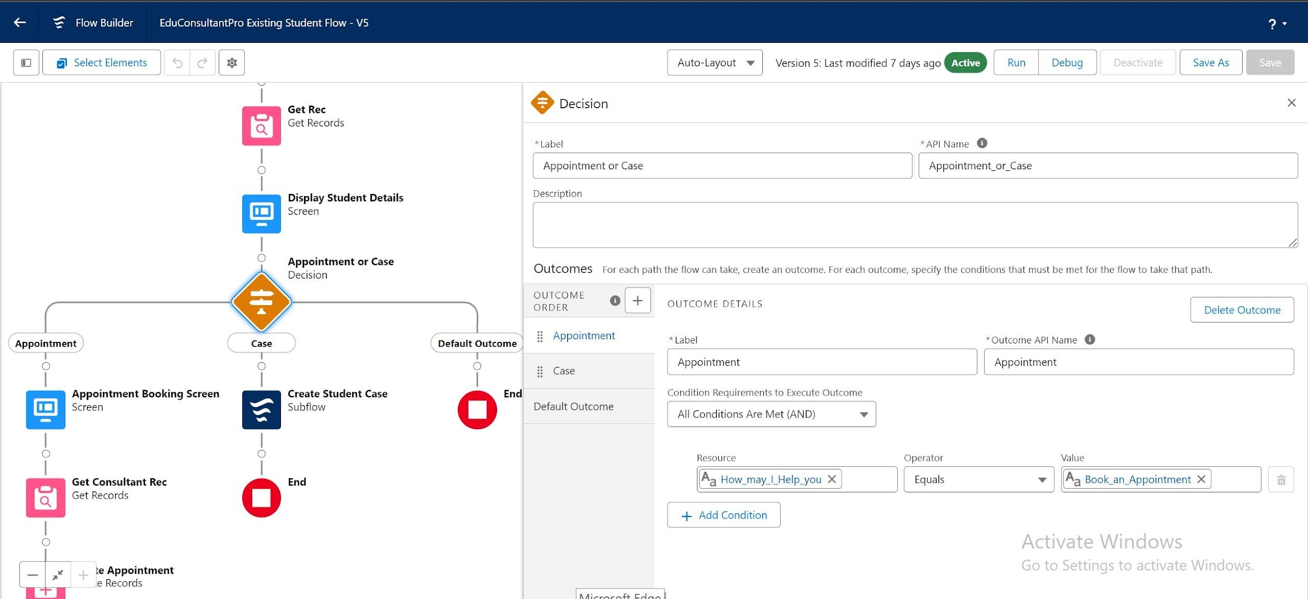

**Fig.6.3.1 Appointment or Case Decision Element**

* Set the Outcome label as “Appointment” with the following condition:
  1. Resource: {!How_may_I_Help_you}, Operator: Equals, Value:

{!Book_an_Appointment}.

* Repeat step 2 for the Case option.
* Add a Screen Element on the Appointment path, label it “Appointment Booking Screen.”
* Create a new Resource (AppointmentRecordRes) to display fields from the Appointment object.
* Drag the fields onto the screen to collect student information.

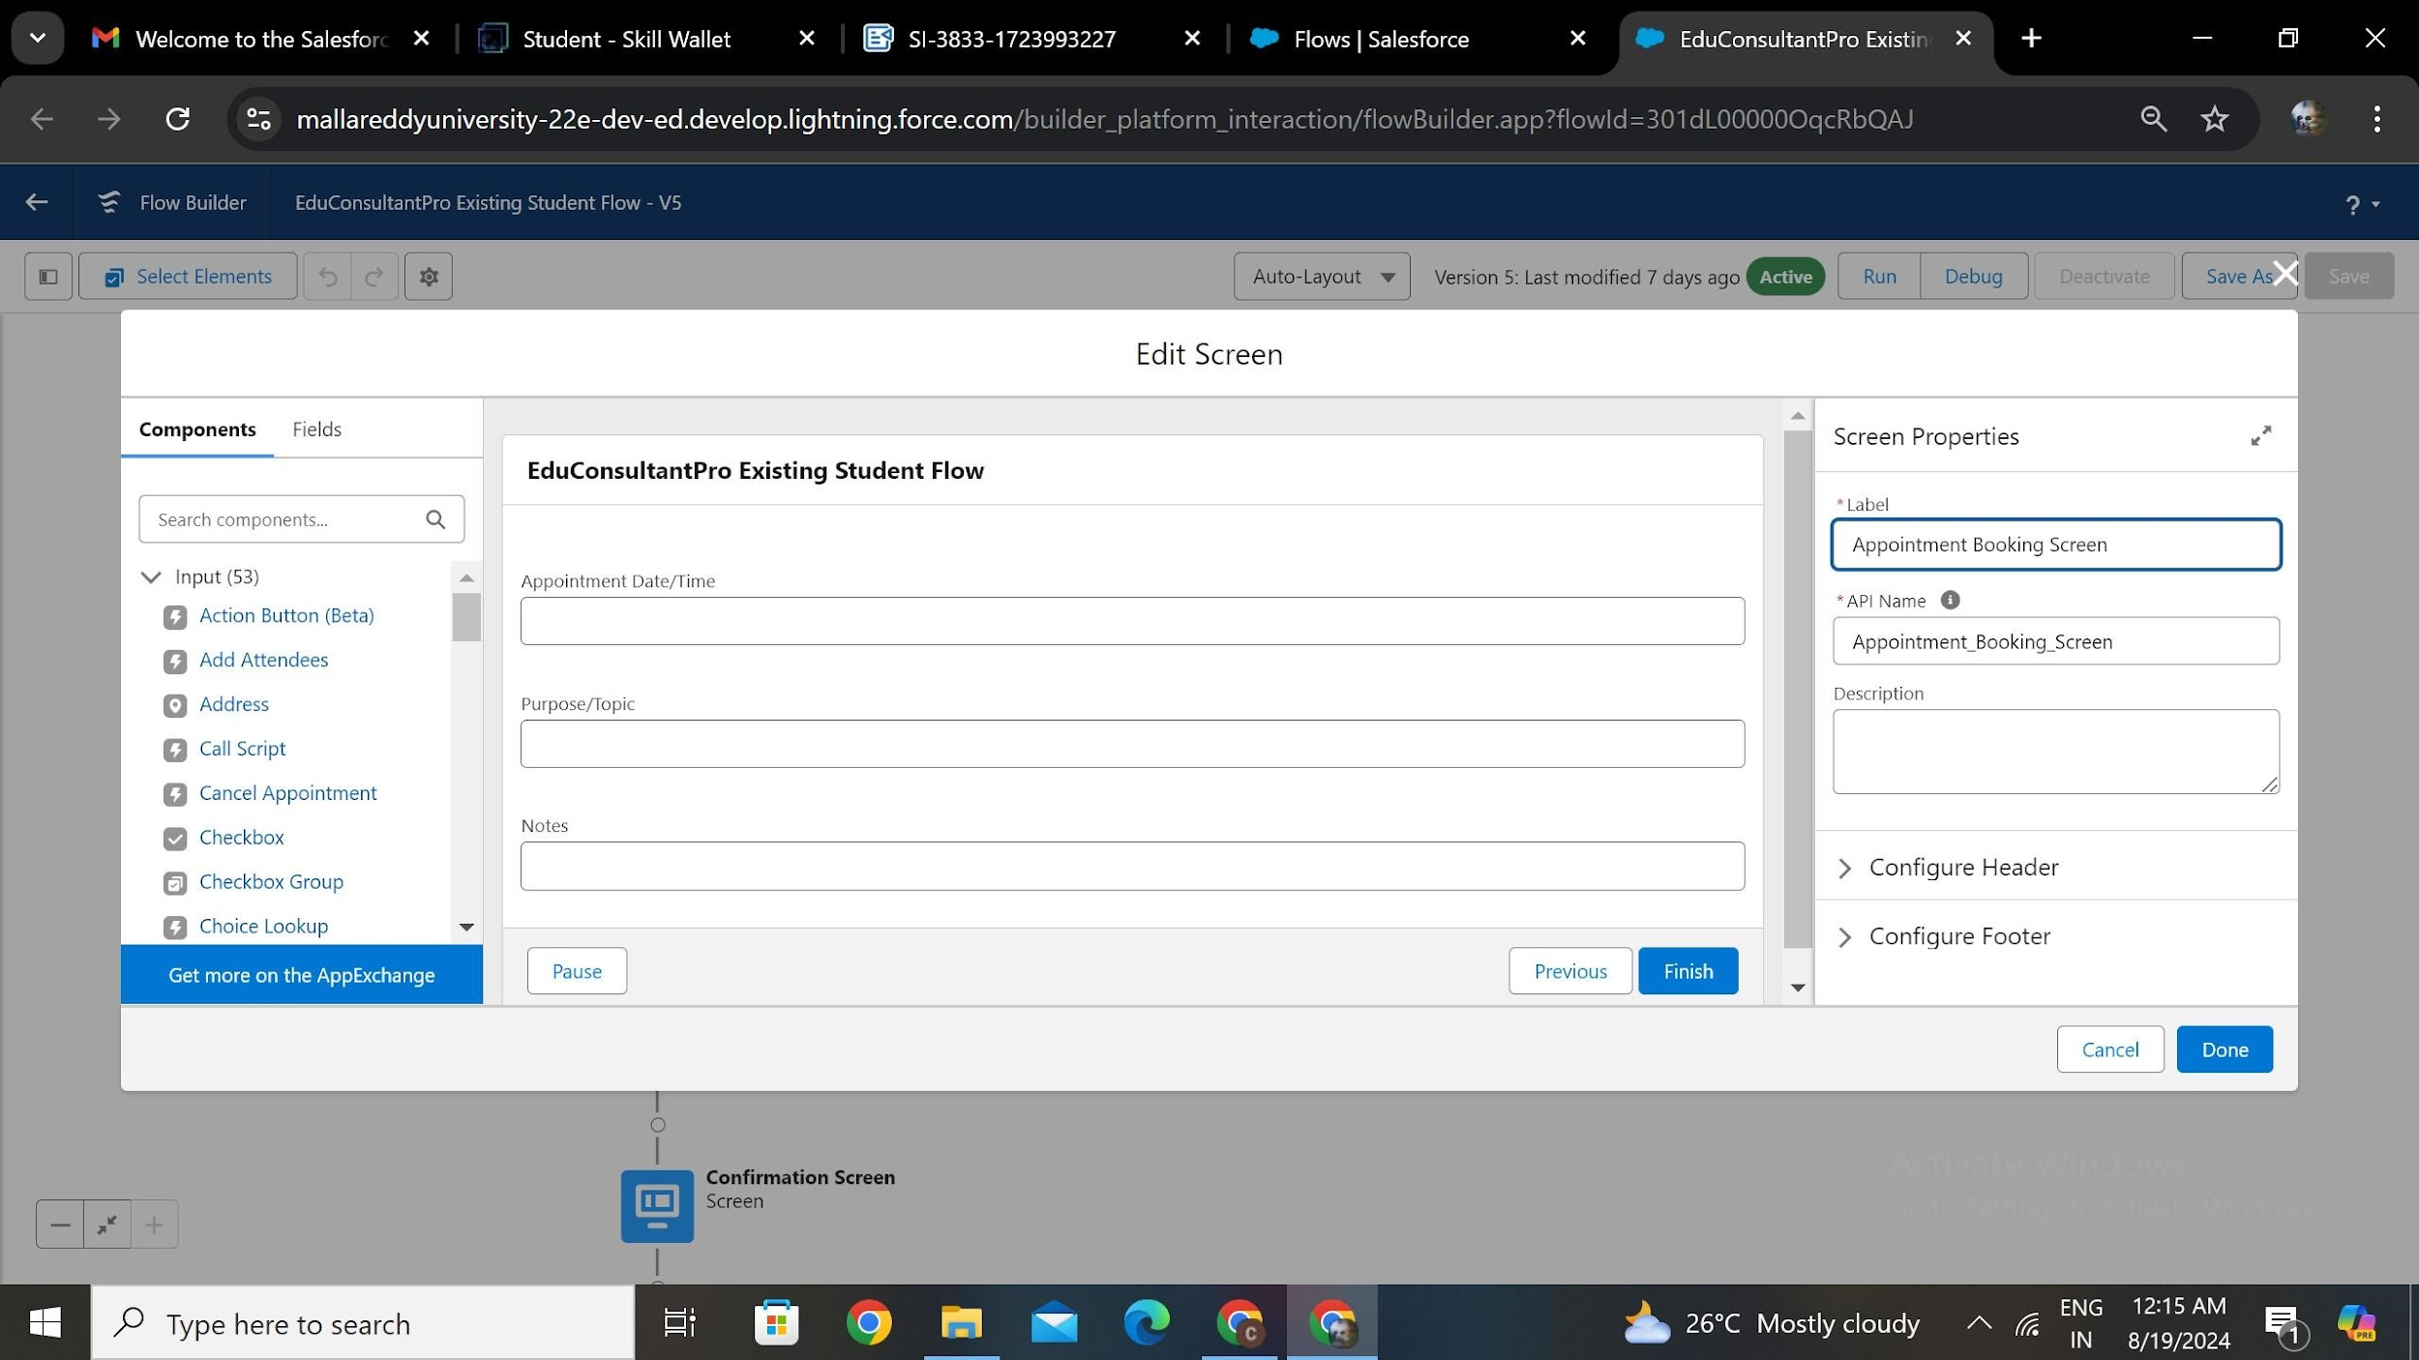

**Fig.6.3.2 Appointment Booking Screen Element**

* Add a GET Record Element on the Appointment path, label it “Get Consultant Rec.”
* Set the Object to Consultant and apply the following condition:
  1. Field: Name, Operator: Equals, Value:

{!AppointmentRecordRes.Consultant_Name__c}.

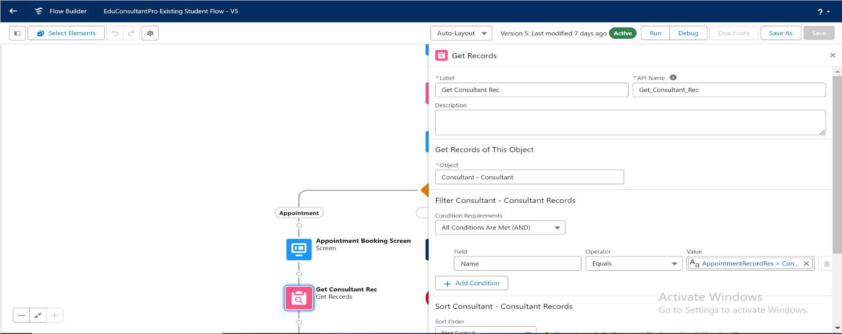

**Fig.6.3.3 Get Consultant Record Element**

## **6.4 CREATE RECORDS**

* Add a Create Records Element after Get Consultant Rec, label it “Create Appointment.”
* Select "one" for how many records to create, and "Use separate resources, and literal values" for setting record fields.
* Map the fields as follows:
  1. Appointment_DateTime__c :

{!AppointmentRecordRes.Appointment_DateTime__c}.

* 1. Consultant__c : {!Get_Consultant_Rec.Id}.
  2. Notes__c : {!AppointmentRecordRes.Notes__c}.
  3. PurposeTopic__c : {!AppointmentRecordRes.PurposeTopic__c}.
  4. Student_Name__c : {!Get_Rec.Id}.

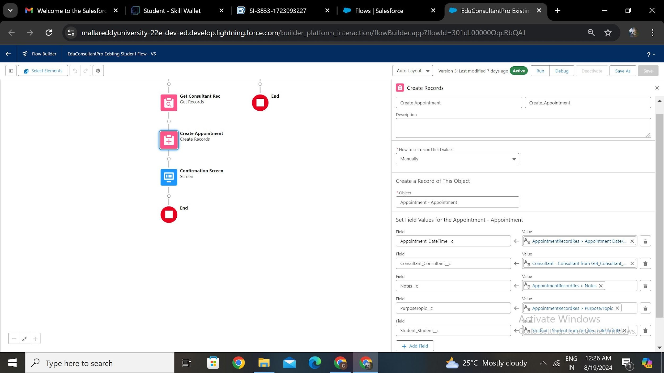

**Fig.6.4.1 Create Appointment Record**

* Add a Screen Element after the Send Email to Student Action Element, label it “Confirmation Screen.”
* Drag a Display Text component to the main panel, label it as

“Appointment_Confirmation.”

* Paste the following in the Resource picker box:
  1. Consultant Name: {!Get_Consultant_Rec.Name}.
  2. Date & Time: {!AppointmentRecordRes.Appointment_DateTime__c}.
  3. Notes: {!AppointmentRecordRes.Notes__c}.

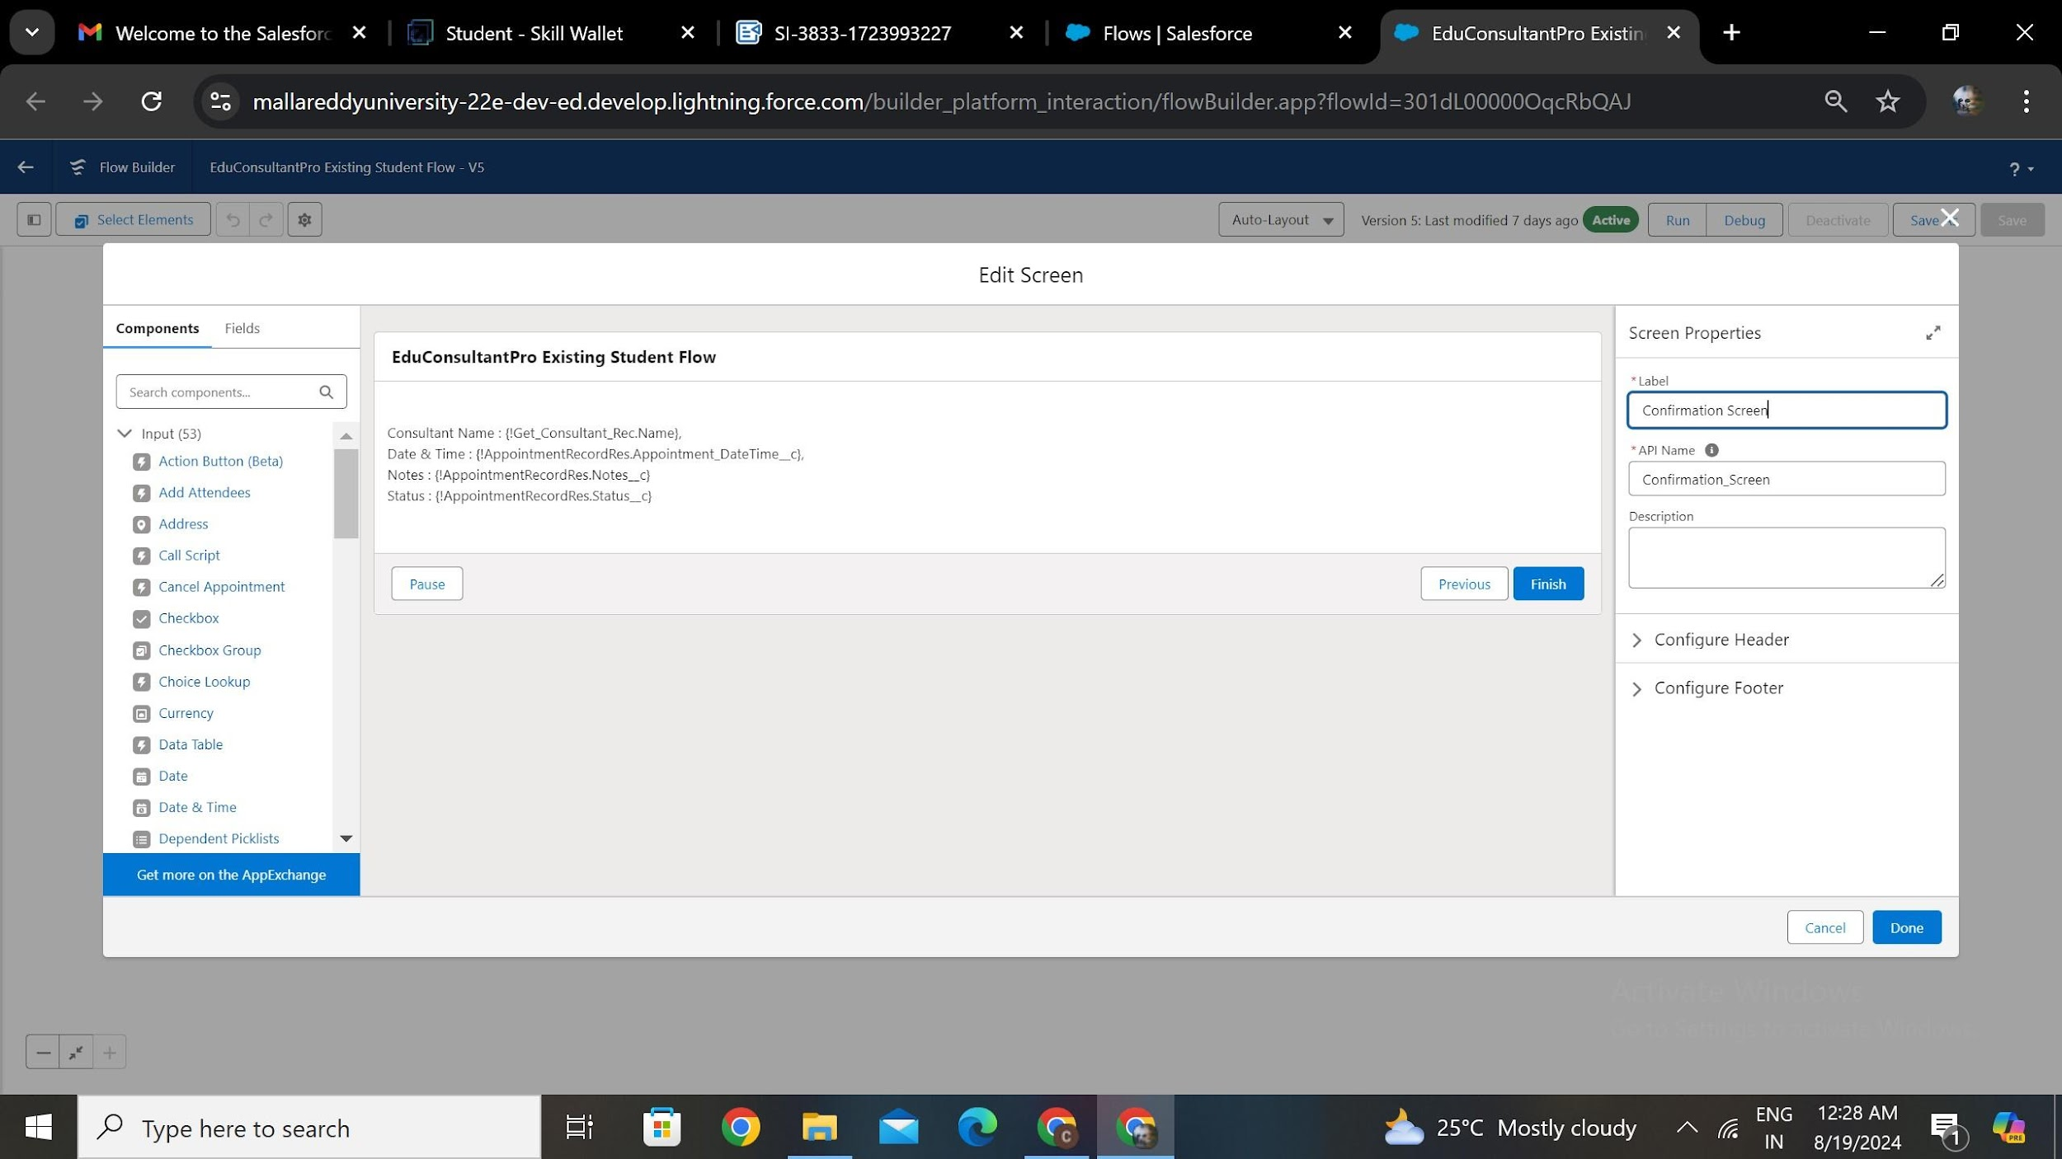

**Fig.6.4.2 Confirmation Screen Element**

## **6.5 ADD SUB FLOW ELEMENTS**

* Add a SubFlow Element on the Case path, search and select “Create a Case,” label it as “Create Student Case.”

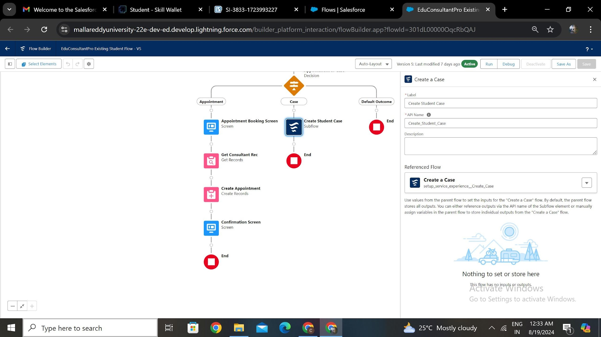

**Fig.6.5.1 Create Student Case Sub Flow Element**

* Save the flow and label it “EduConsultantPro Existing Student Flow.”

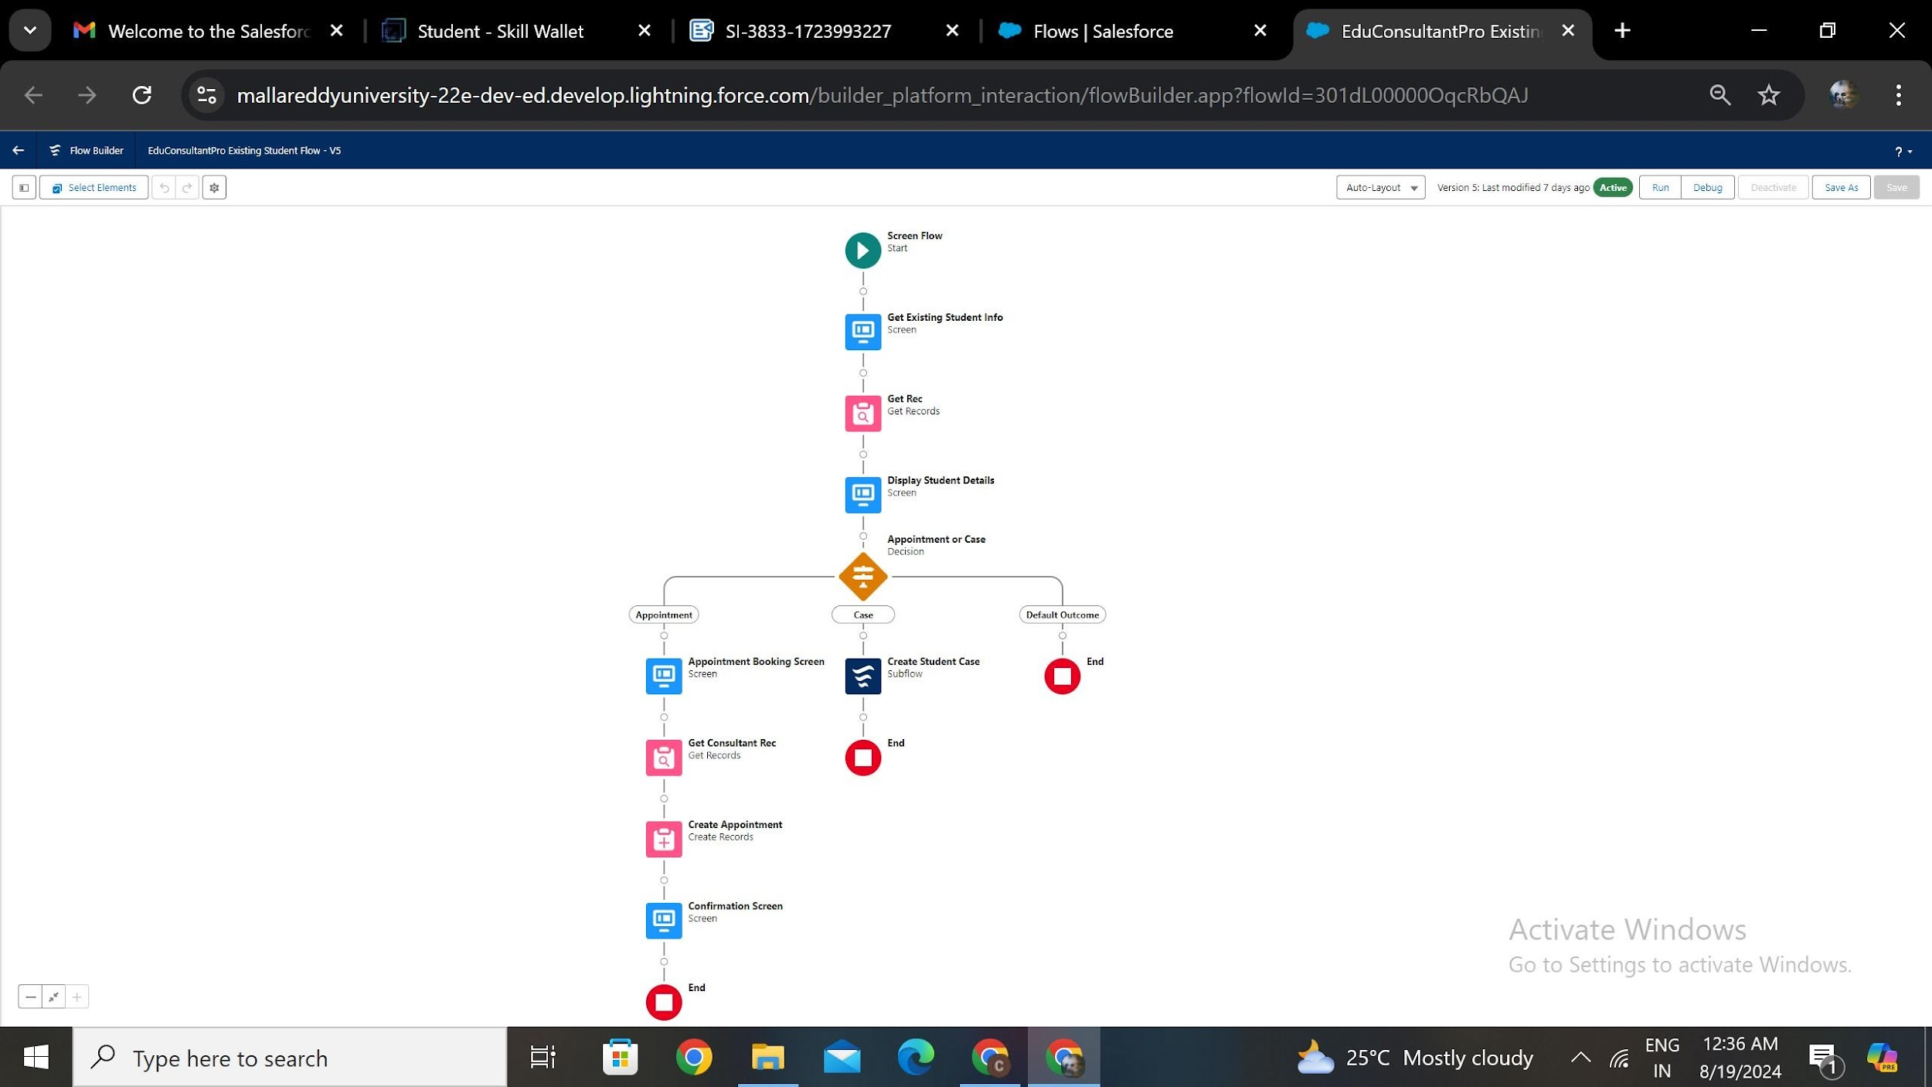

**Fig.6.5.2 EduConsultantPro Existing Student Flow**

**TASK 7**

**CREATE UNIFIED SCREENFLOW**

To streamline the student onboarding and appointment booking process at EduConsultantPro, a comprehensive ScreenFlow will be created. This ScreenFlow will guide users through a tailored experience based on whether they are new or existing students. It integrates all essential subflows, ensuring a seamless and efficient process for both categories of students.

### **7.1 ADD SCREEN ELEMENTS**

* Add a Screen Element and label it as "Welcome Screen."
* Add a Display Text component labeled "SuccessMessage" and paste the welcome message content.

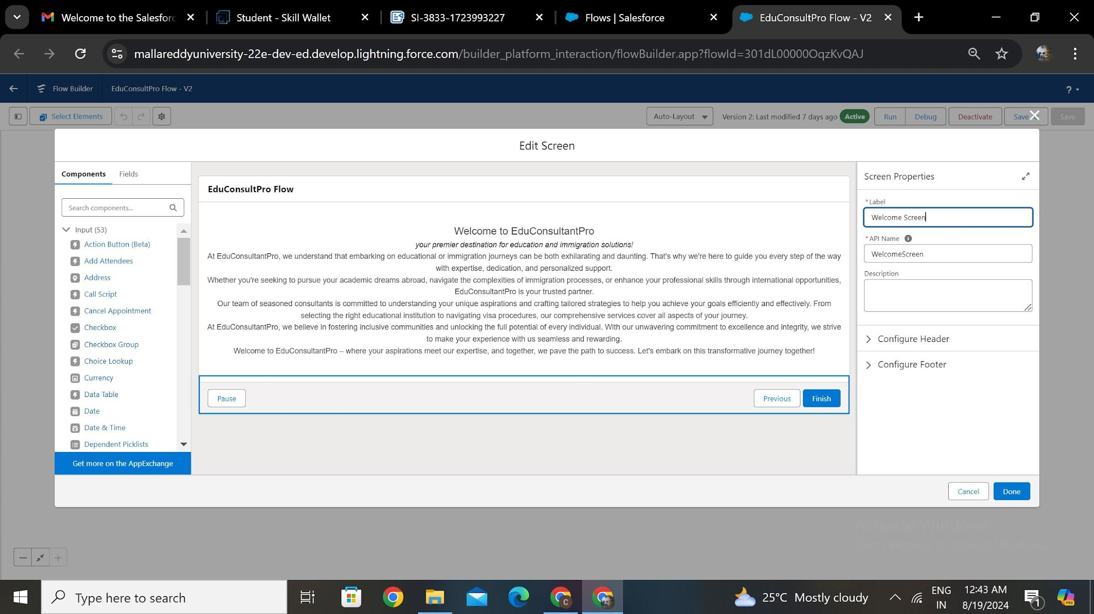

**Fig.7.1.1 Welcome Screen - Screen Element**

* Add a Screen Element labeled "Existing or New Student Confirmation Screen."
* Add a radio button component labeled "Are you an Existing Student?"
* Create two choices: "Yes" and "No."

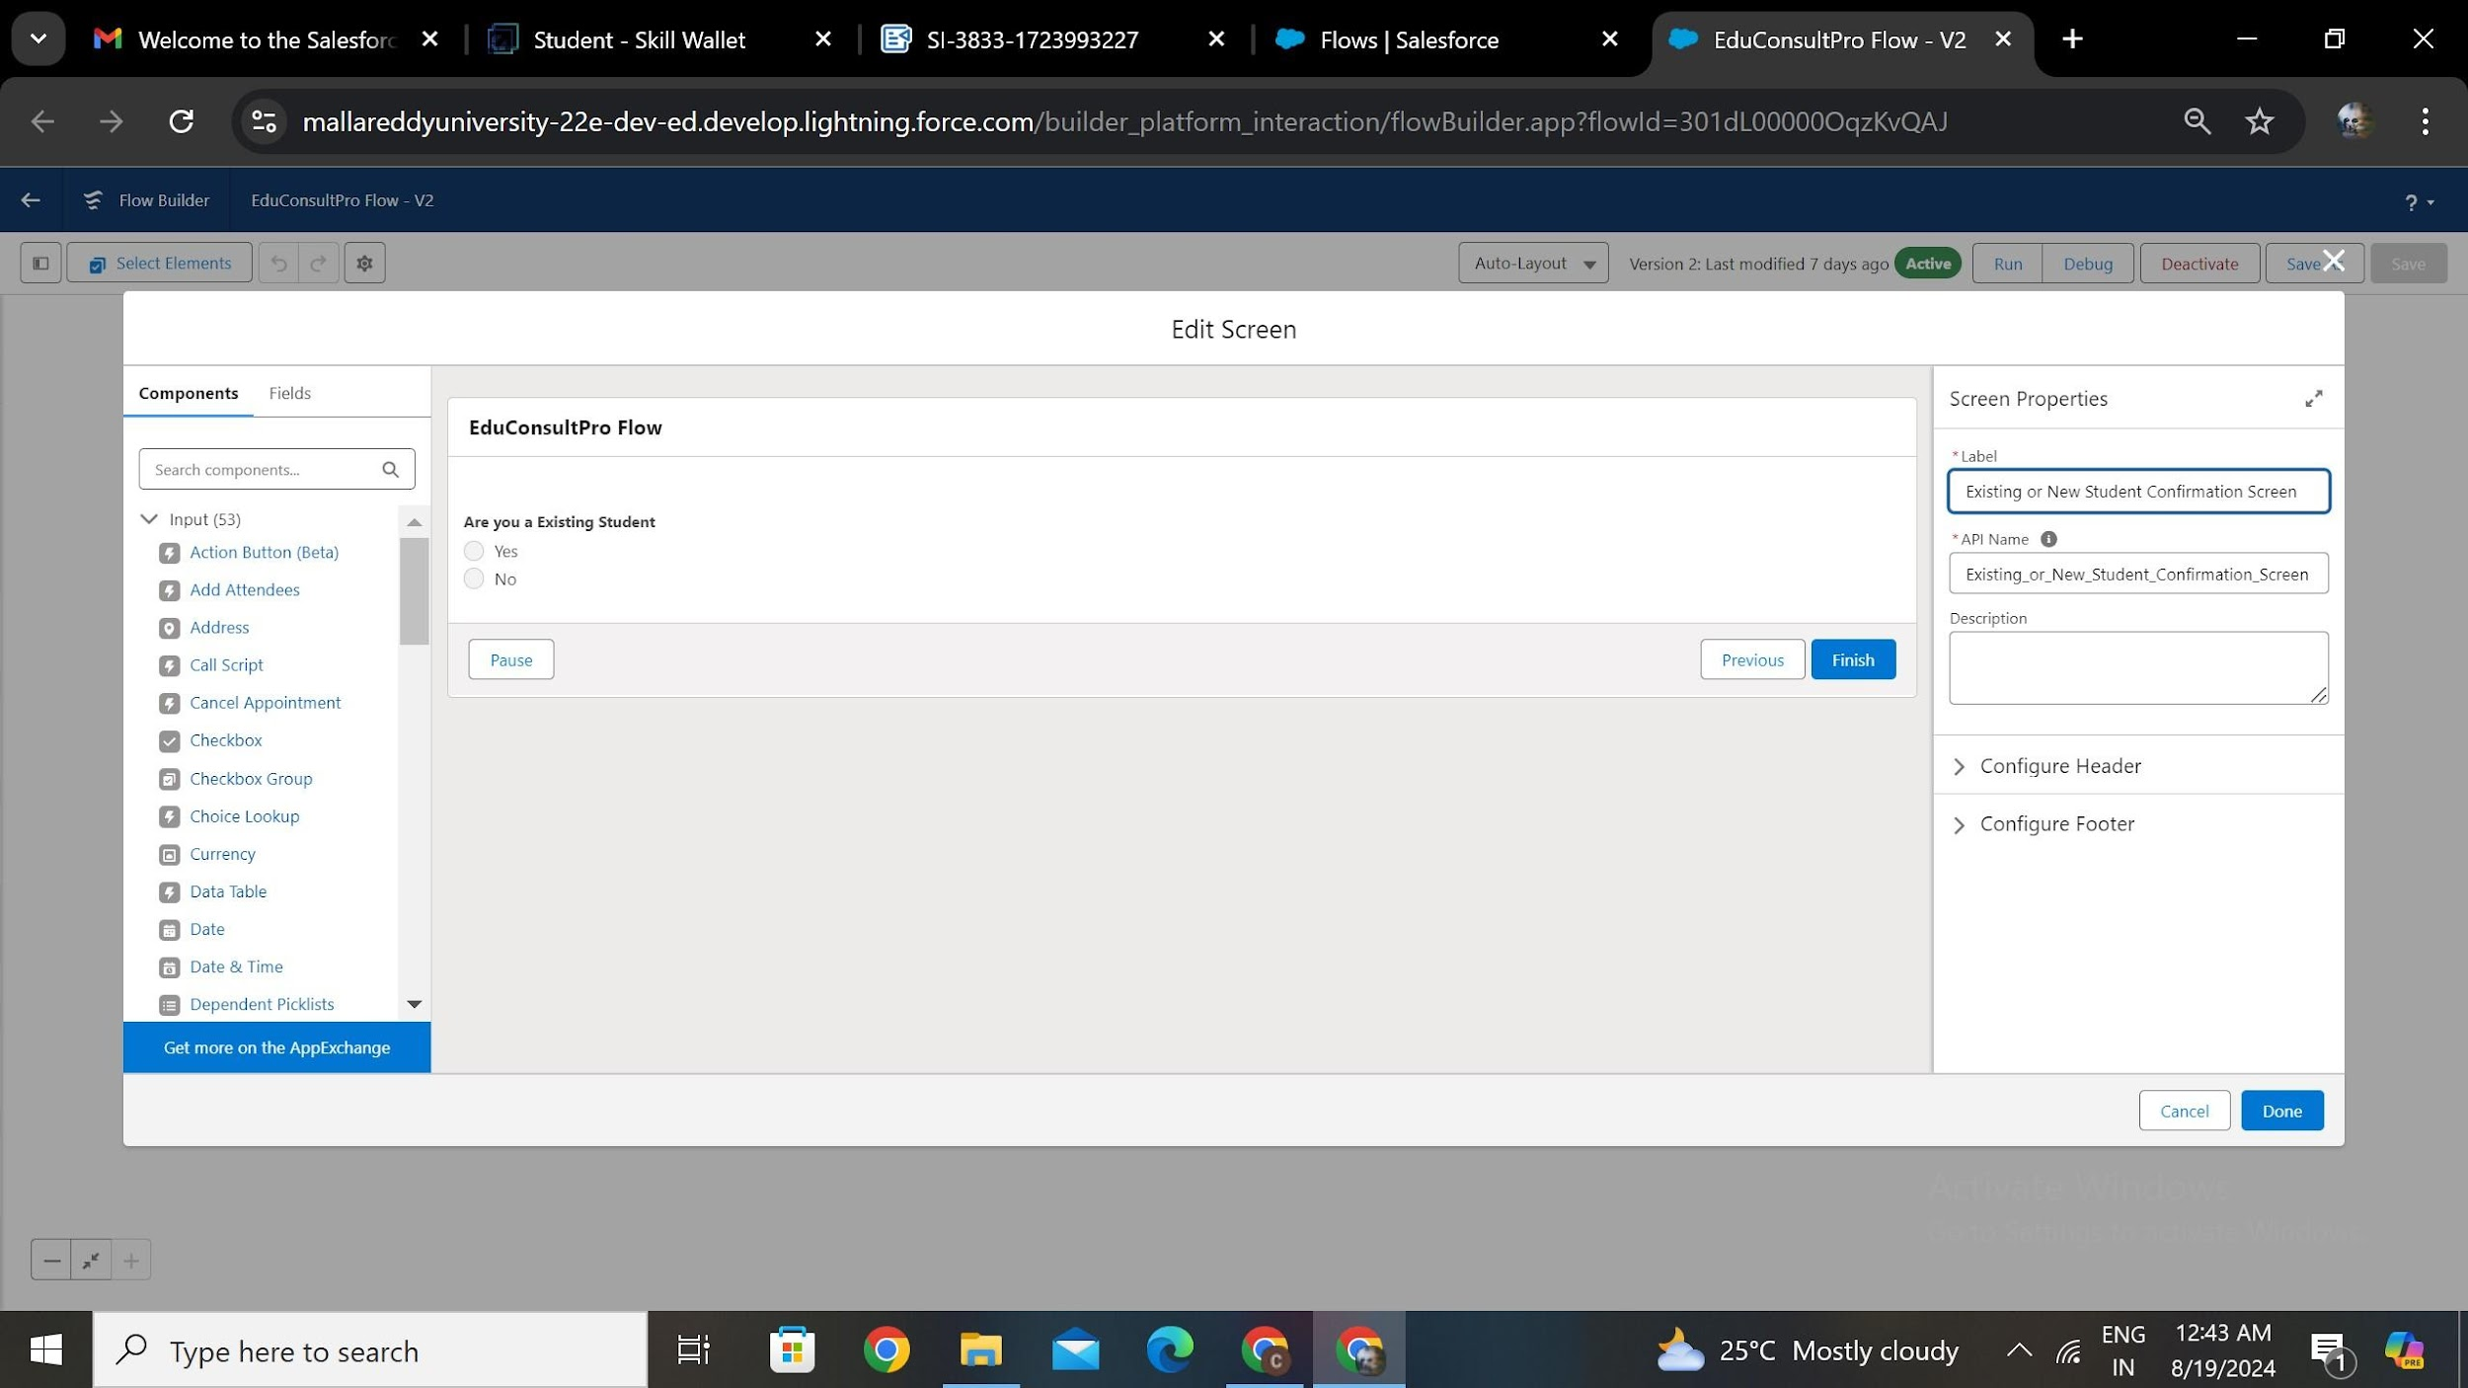

**Fig.7.1.2 Existing Or New Student Screen Element**

### **7.2 ADD DECISION ELEMENTS**

* Add a Decision Element labeled "Decision 1."
* For "If Existing Student," set the condition: Resource = {!Are_you_a_Existing_Student}, Operator = Equals, Value = {!Yes}.
* Repeat the steps for "No" options.

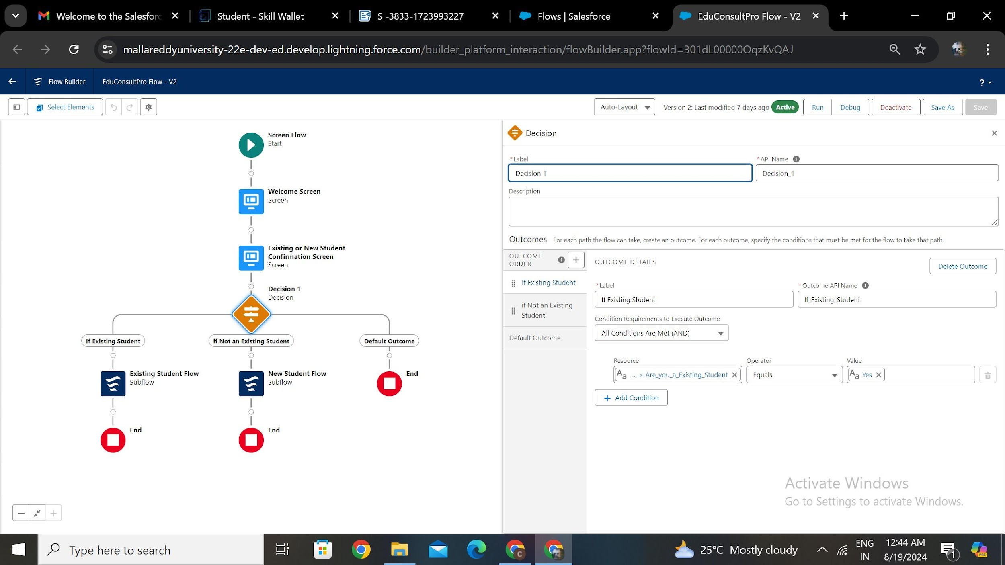

**Fig.7.2.1 Decision Element**

### **7.3 ADD SUB FLOW ELEMENTS**

* Add a SubFlow Element after the Decision Element on the "If Existing Student" path.
* Select the "EduConsultantPro Existing Student Flow" and label it as "Existing Student Flow."

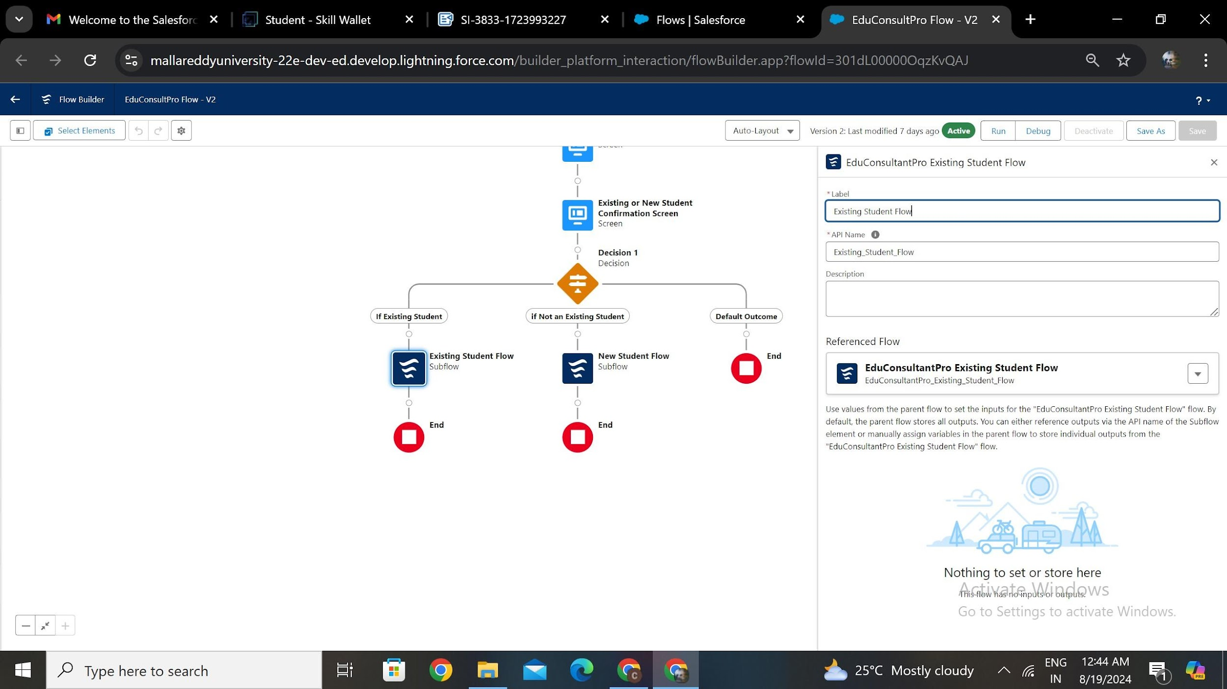

**Fig.7.3.1 Existing Student Sub Flow Element**

* Add a SubFlow Element after the Decision Element on the "If Not an Existing Student" path.
* Select the "EduConsultantPro Student Flow" and label it as "New Student Flow."

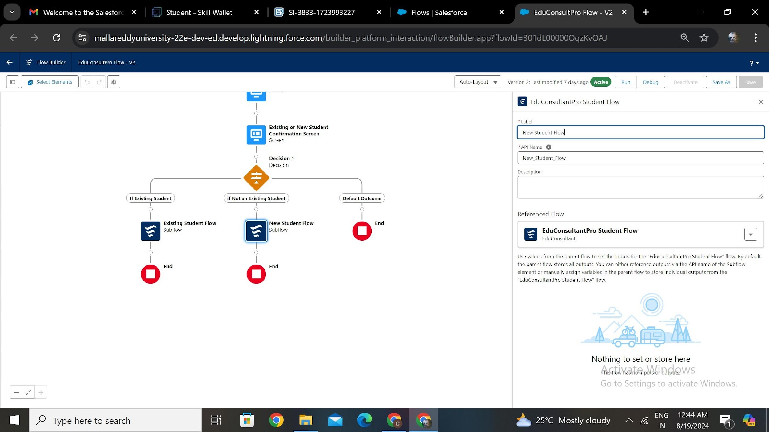

**Fig.7.3.2 New Student Sub Flow Element**



**Fig.7.3.3 EduConsultant Flow**

# **TASK 8**

# **CREATE A LIGHTNING APP PAGE**

* From Setup, enter App Builder in the Quick Find box, then click Lightning App Builder.
* Click New, select Home Page, then click Next.
* Name the page “EduConsultPro Home Page,” select the Standard Home Page template, and click Done.
* Drag the Flow component to the top-right region, and search for the “EduConsultantPro Flow.”
* Click Save, then Activate. Assign it to the Sales app and the System Administrator profile, then click Save.

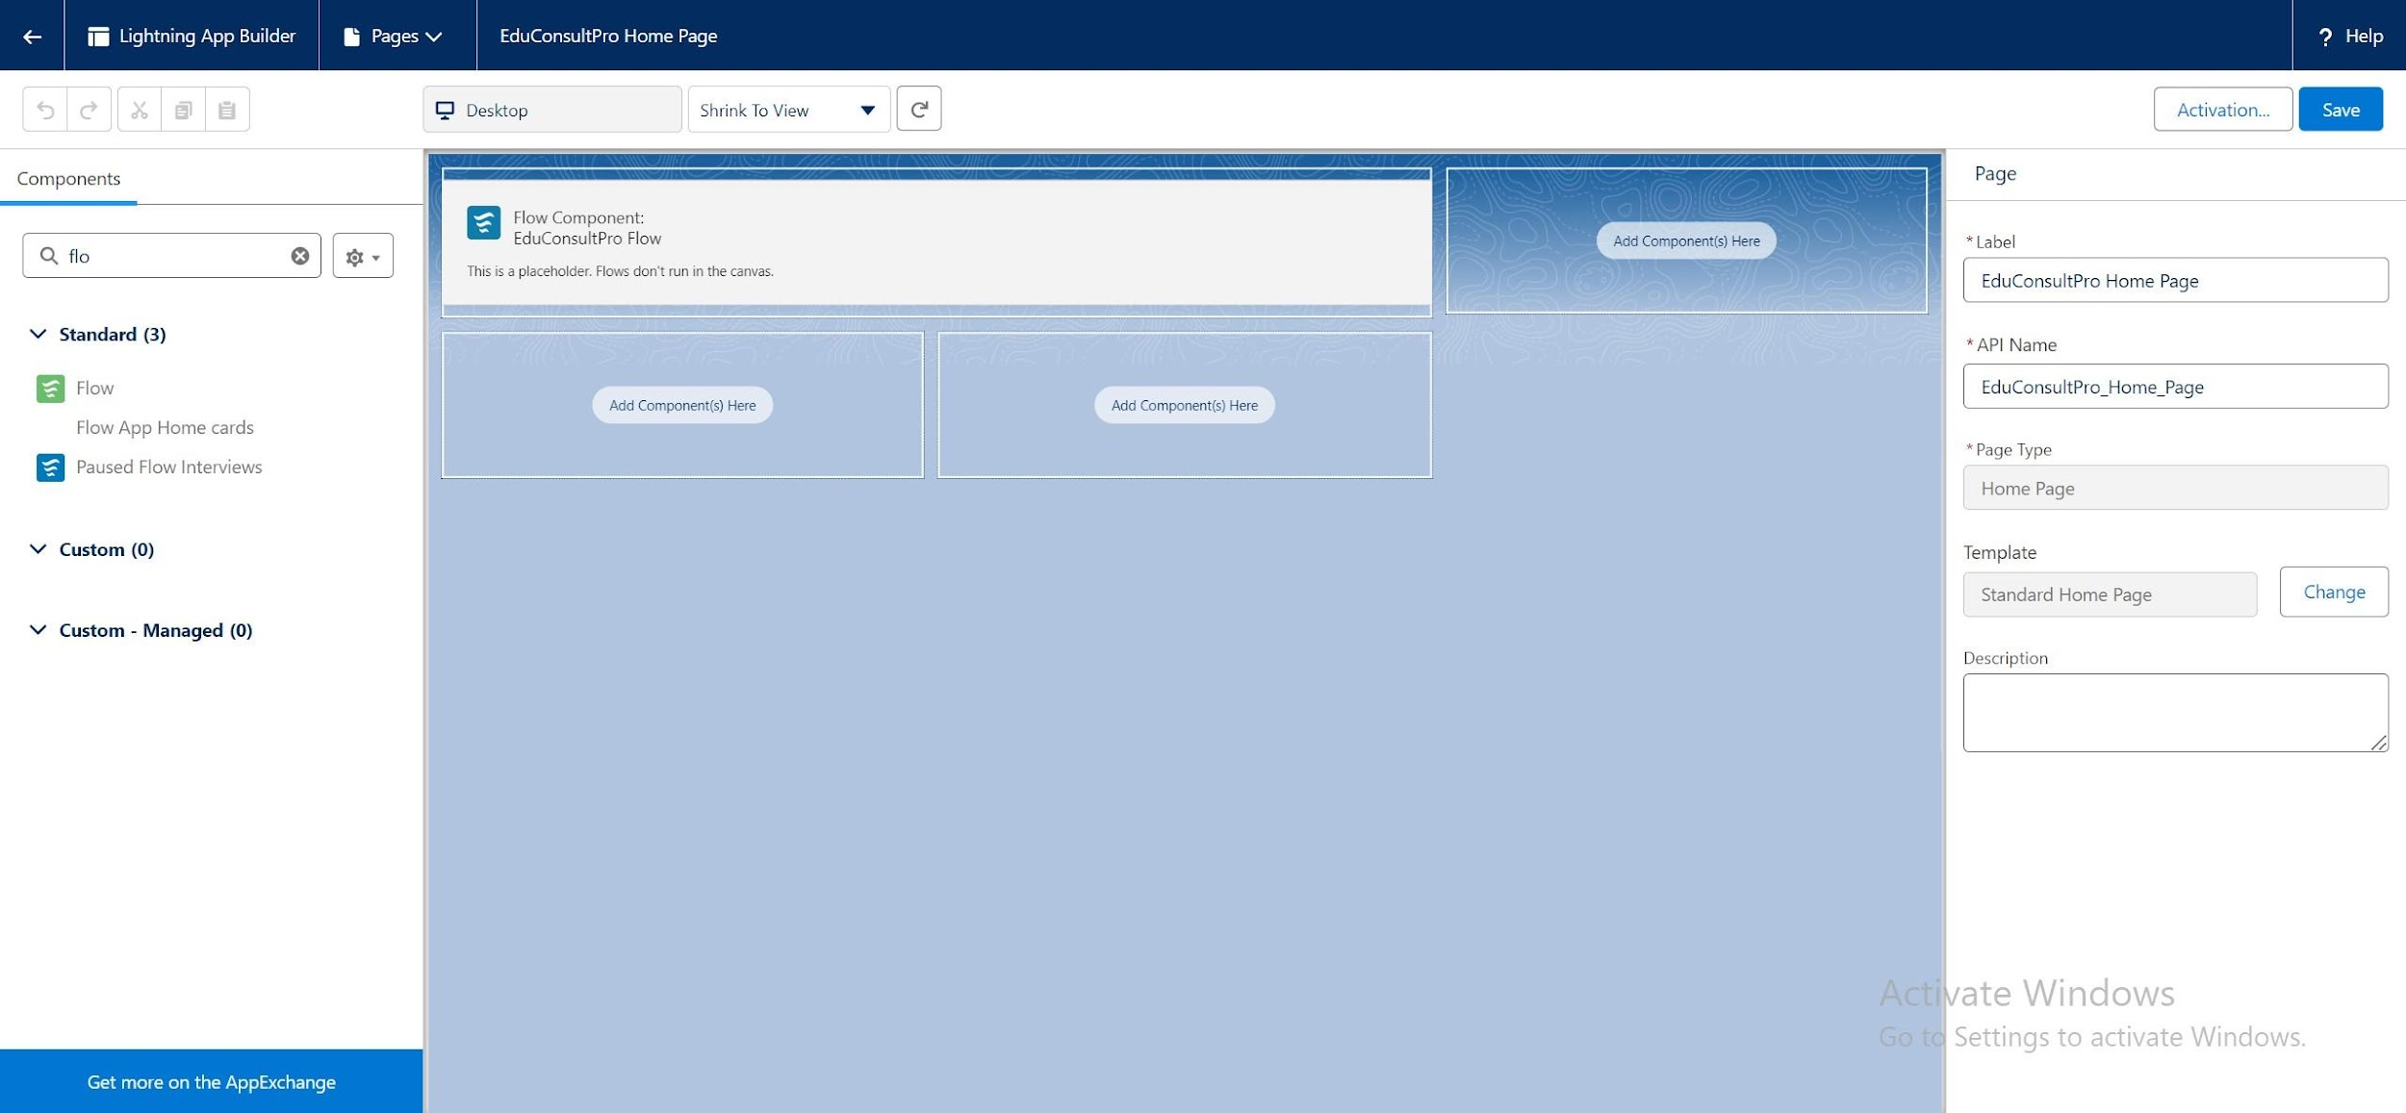

**Fig.8.1 Configuring the EduConsultPro Home Page in the Lightning App Builder**

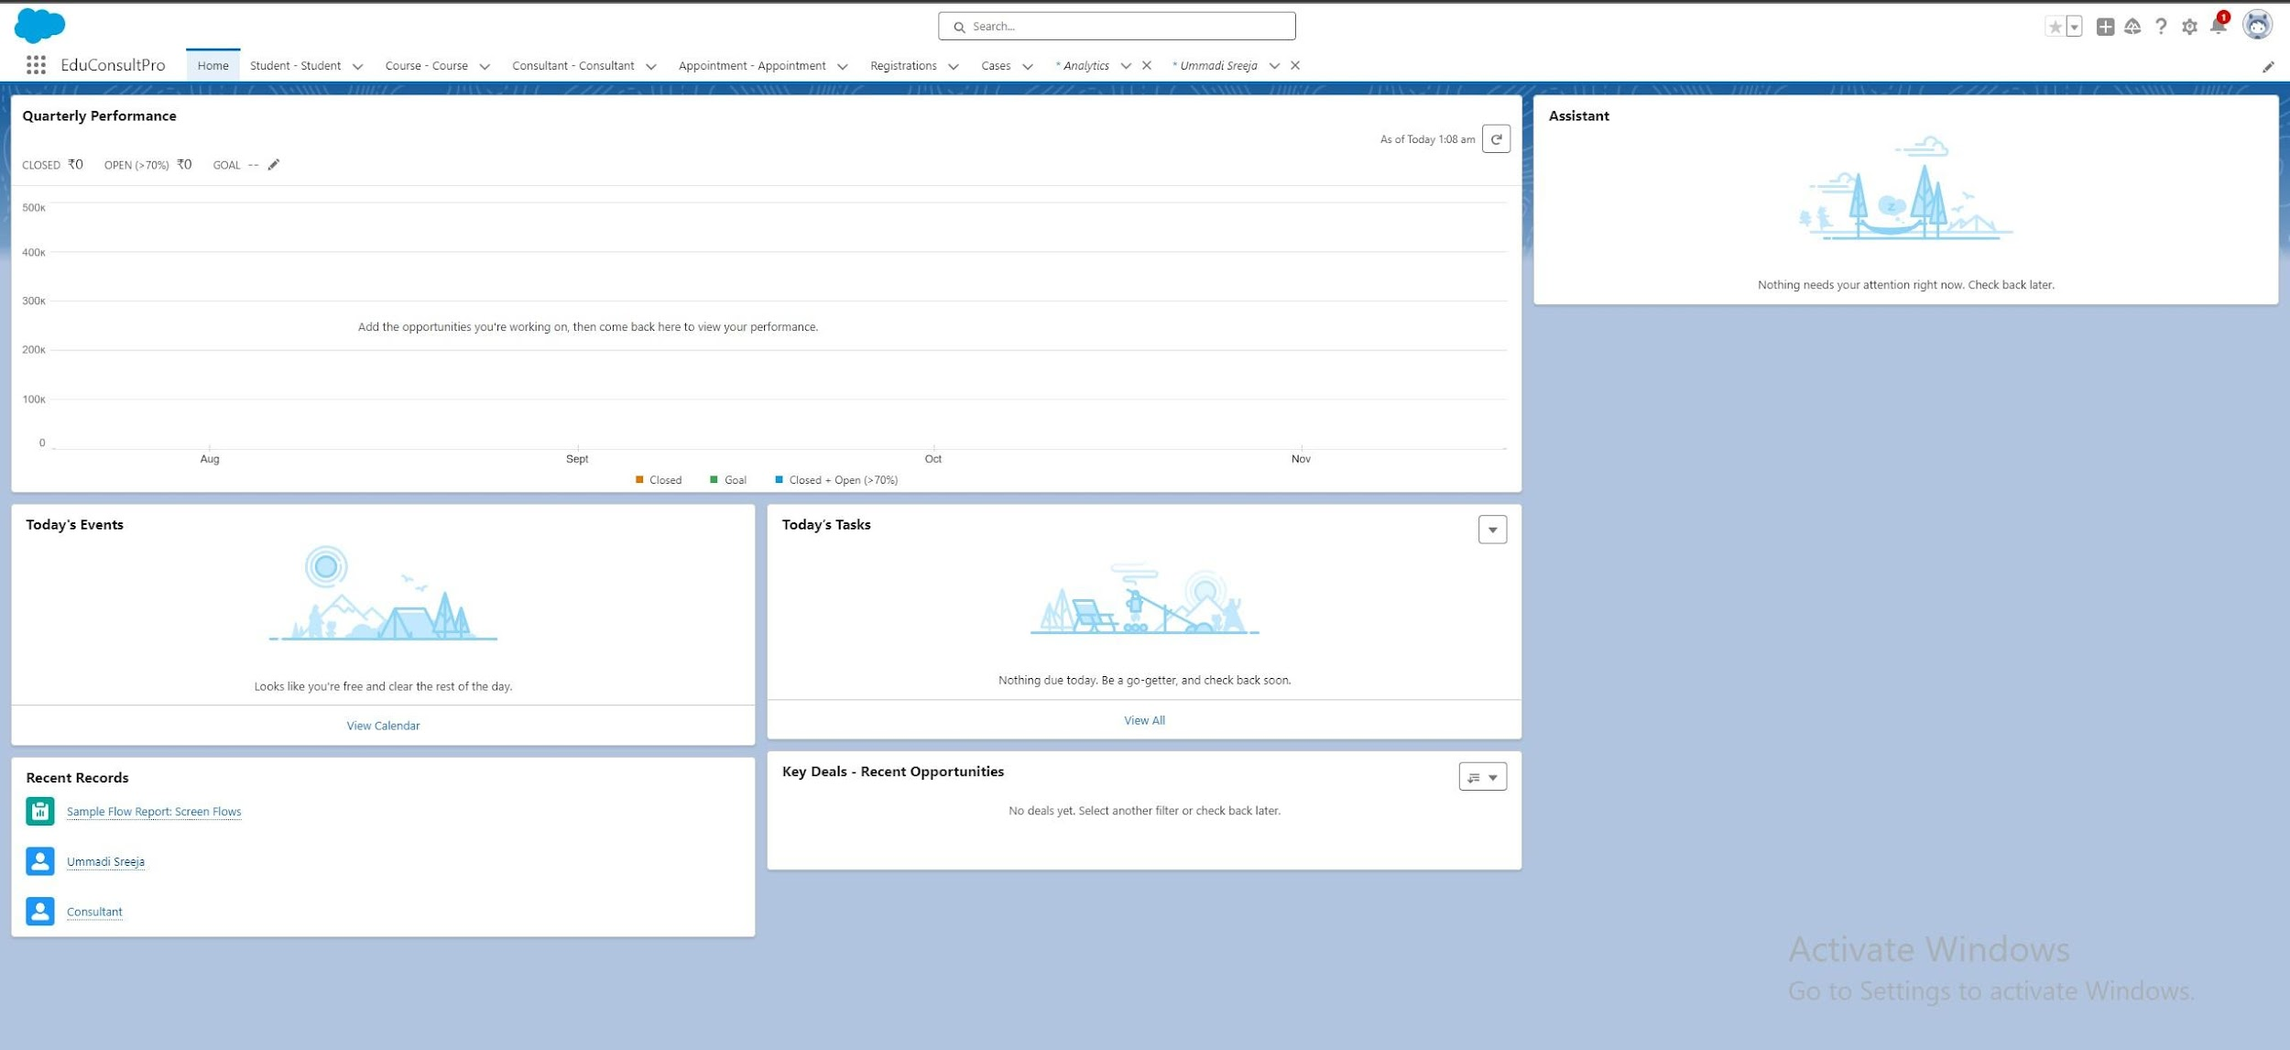

**Fig.8.2 EduConsultPro Home Page: Dashboard View After Setup in Salesforce.**

# **THANK YOU**